ME 421 - Advanced CAD
Finite Element Analysis of a C-Clamp
Zakaria Alghamdi
Spring 2019

Table of Contents
Introduction 4
Methods 5
Using SolidWorks 5
Using CATIA 17
Results and Comparison 30
TK solution provided by Dr. Odom 30
SW solution 30
CATIA solution 30
Comparison between TK solution and SW 31
Comparison between TK solution and CATIA 31
Time Comparison 33
Lessons Learned 33

Introduction
A Von-Mises test has been done to the c-clamp by Dr. Edwin Odom using TK- Solver. Dr. Odom was able to find the Von-Mises stresses in four different locations. This document will show the method and the result of doing Von-Mises using SolidWorks, and CATIA. The problem statement is show below: (Please note the origin is denoted as “O” in the figure below)

Methods

Using SolidWorks
After opening the model part in SW:
- Click on simulation.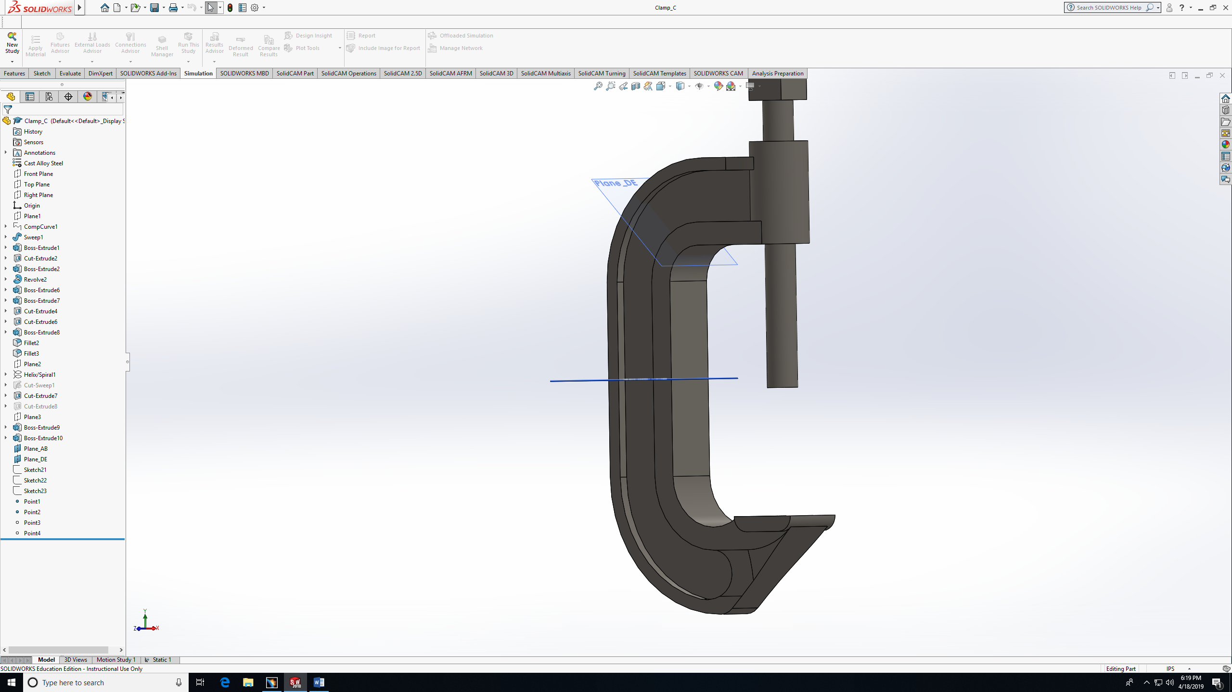
- Study: Statics 1, Click Ok .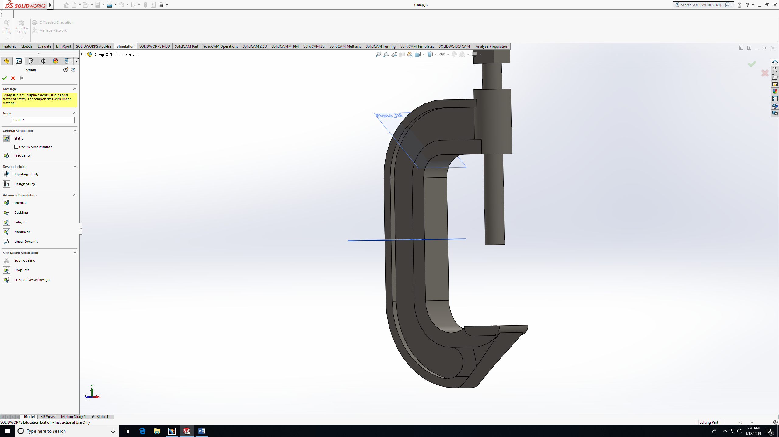
- Statics Study is now avilable. Now you can apply ( fixture, loads, mesh).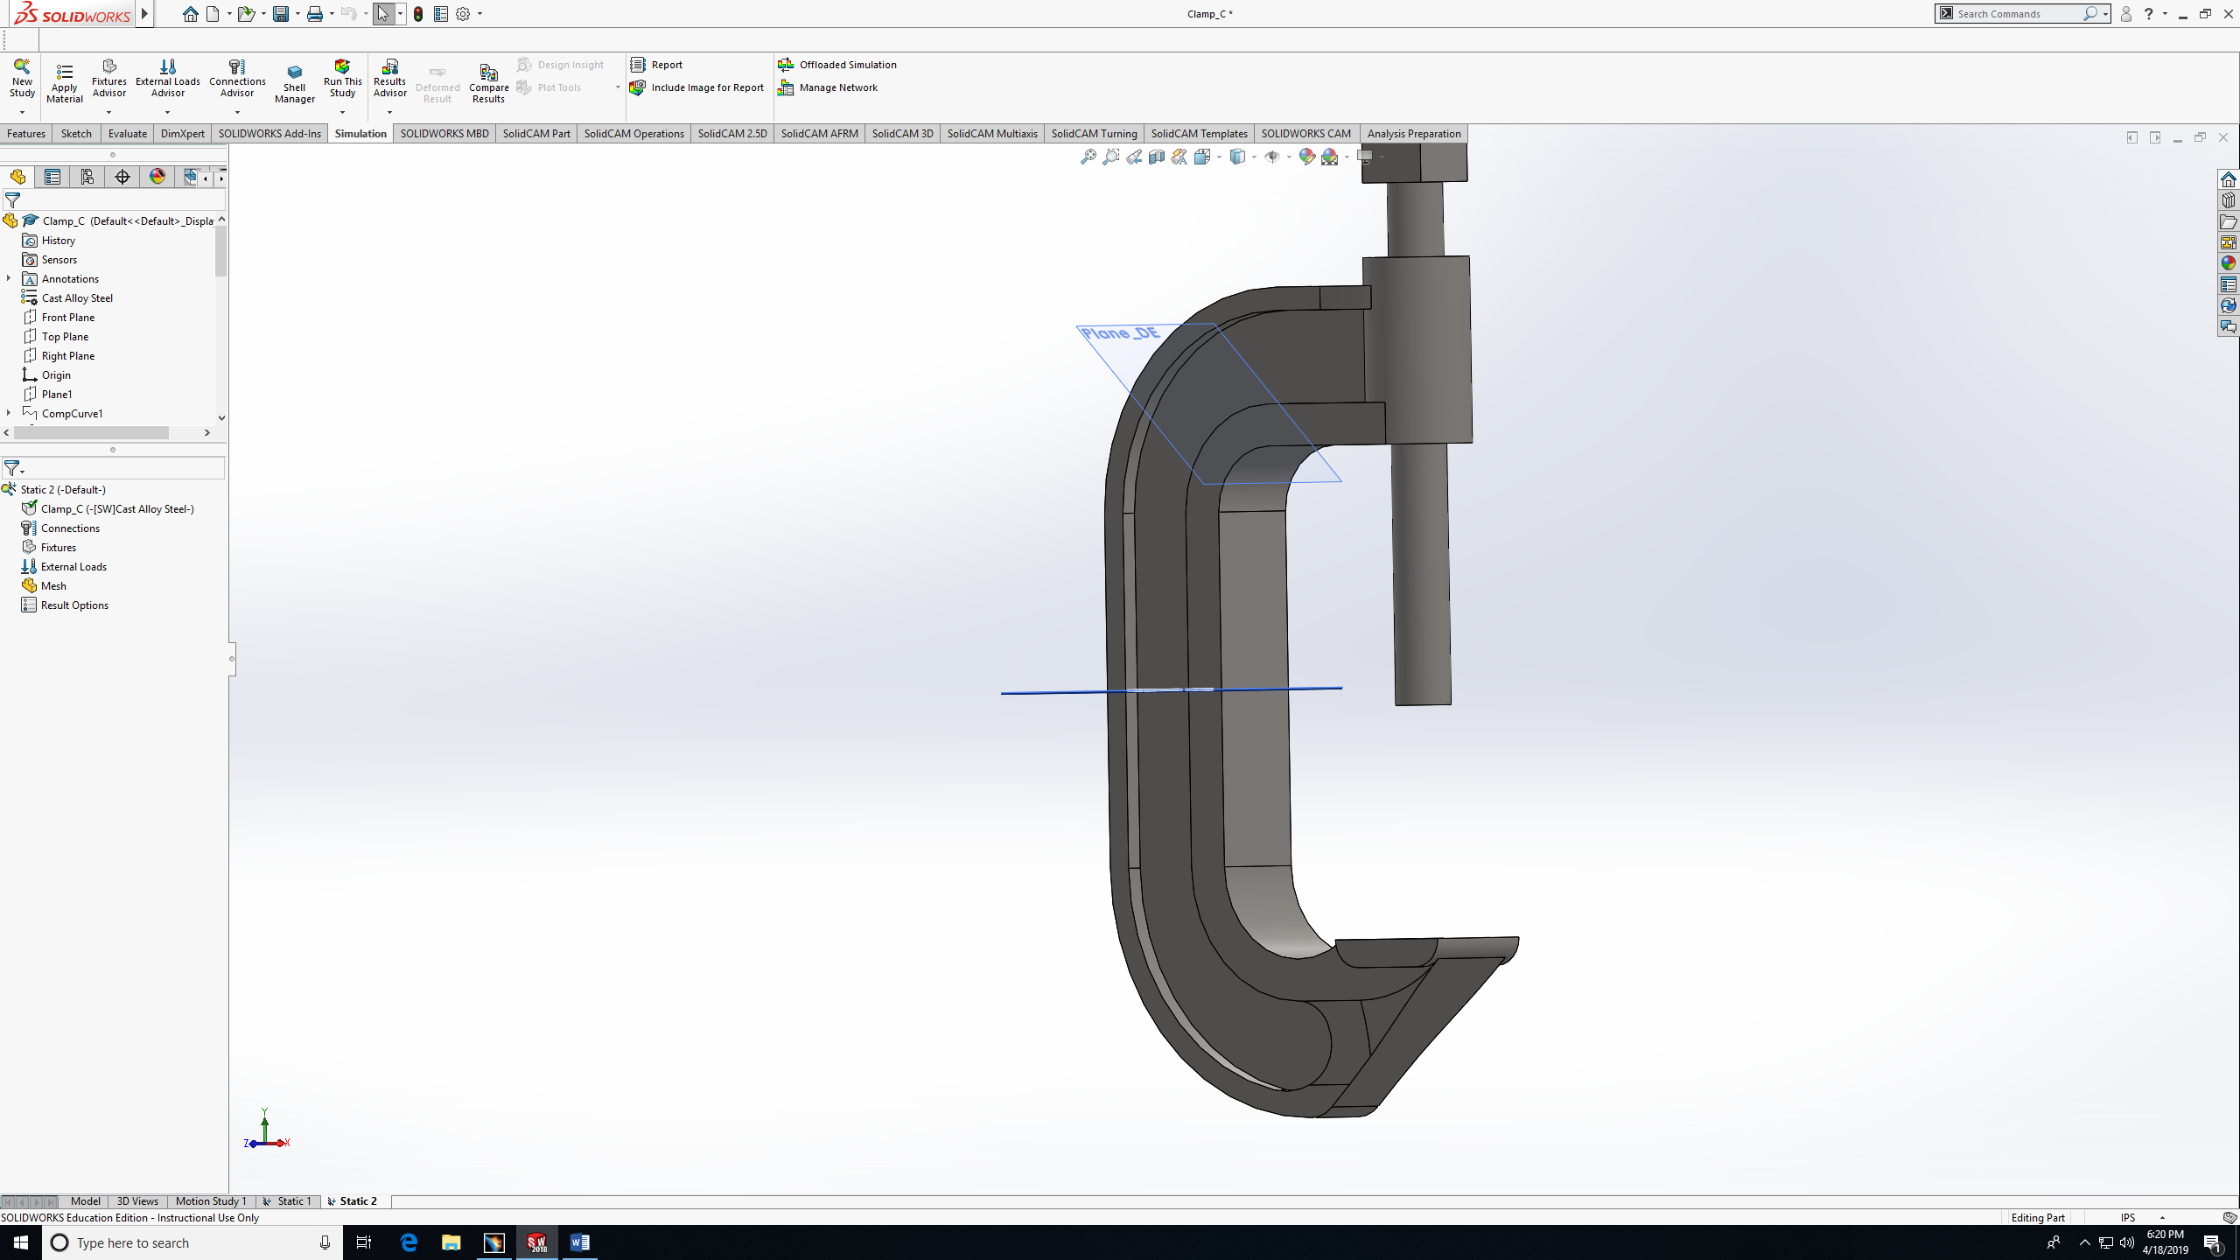
- Right click fixture, then choose fixed geometry. 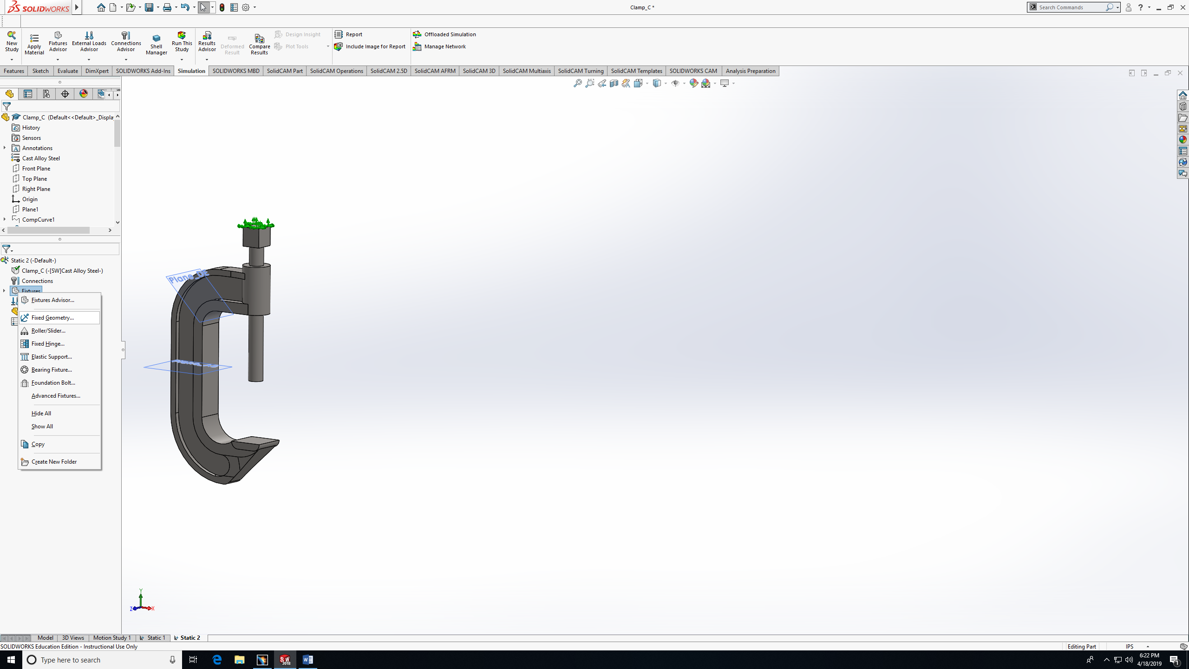

- Choose the top face to be fixed. Then ok.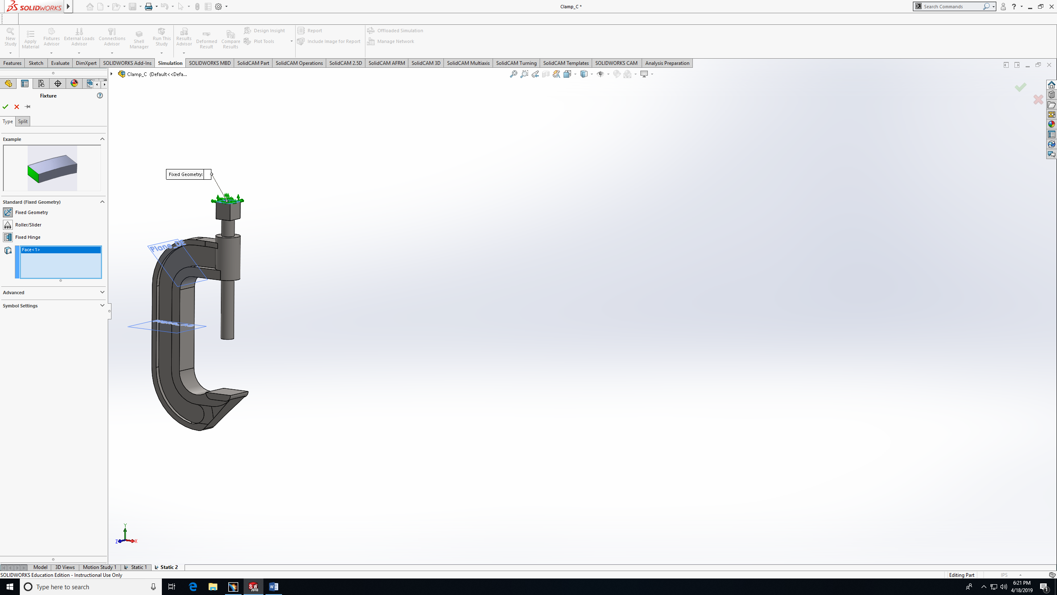
- Add forces by right clicking on External load, then forces.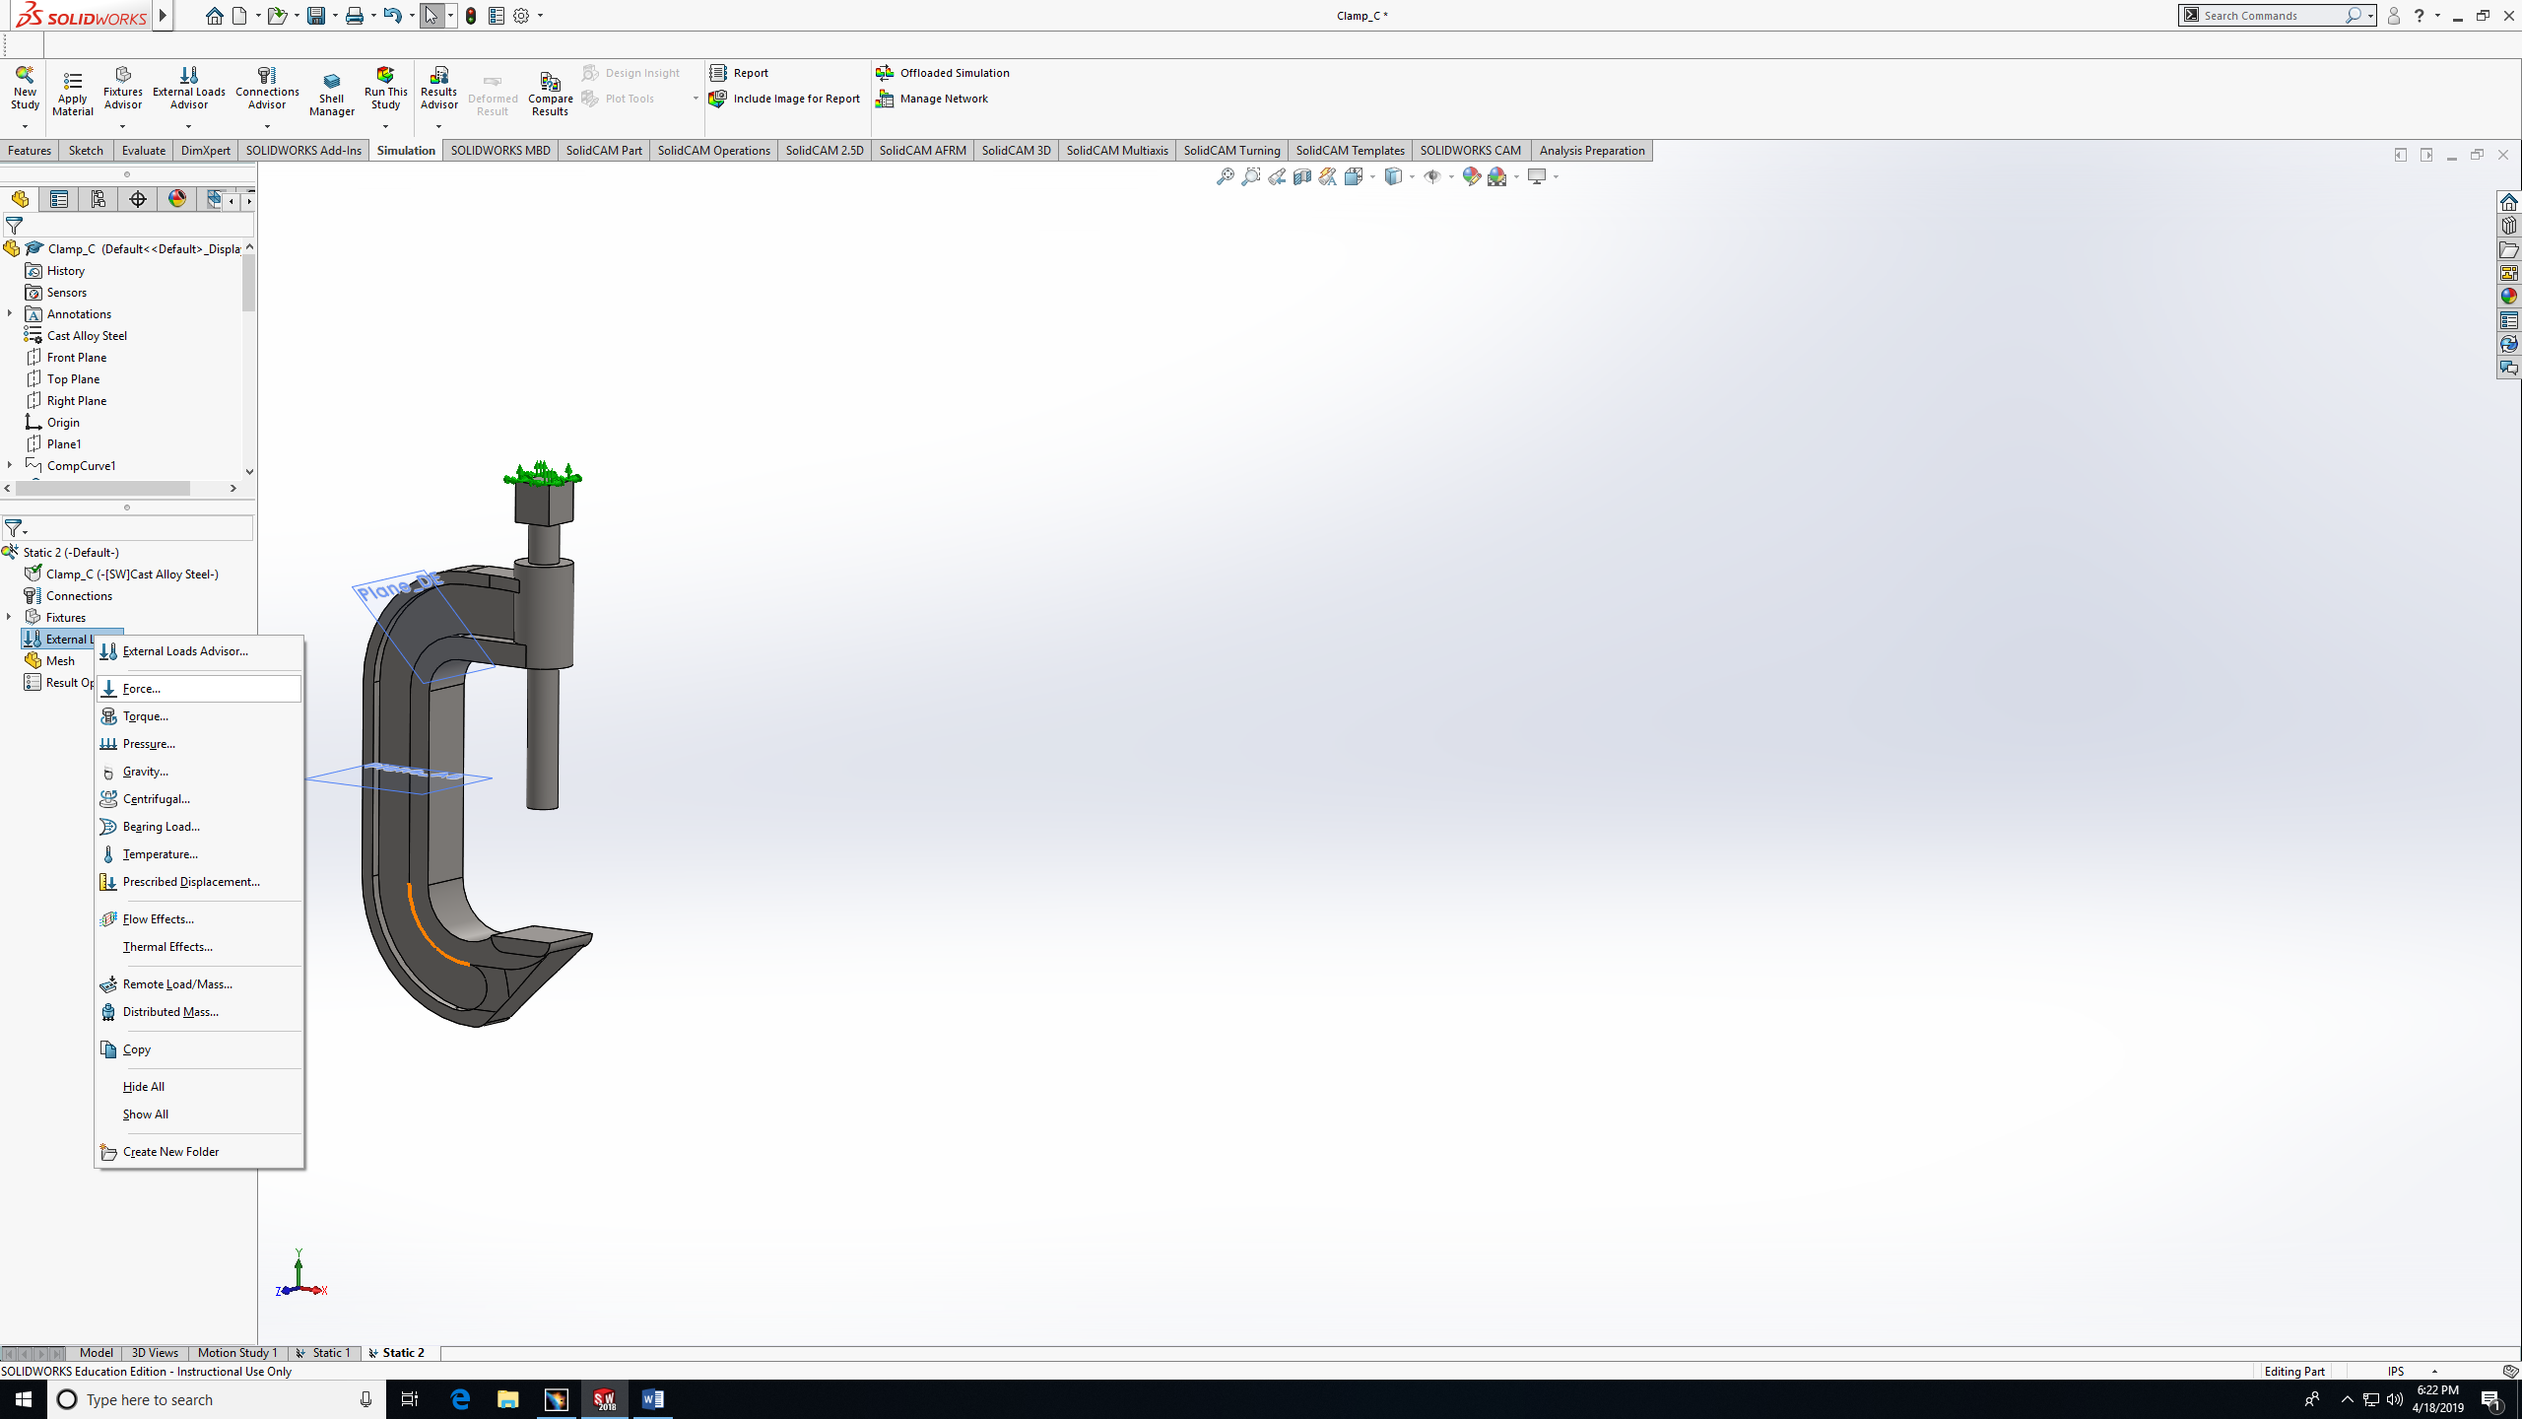
- Choose faces that the force will be applied to. Then fill in the force value and unit. Then Ok.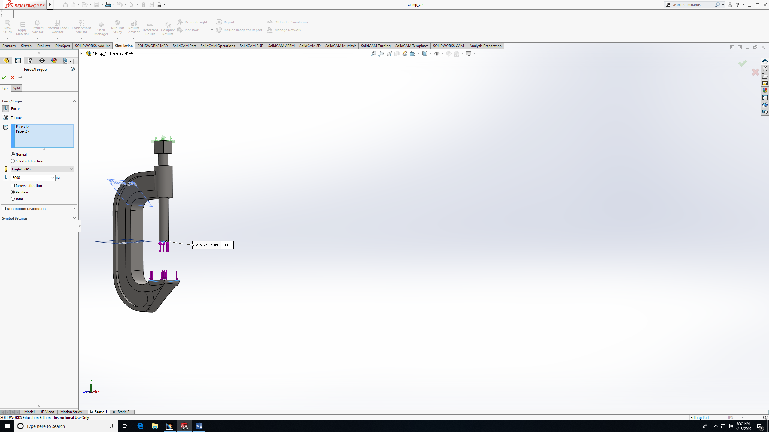
- Create mesh: right click on Mesh. 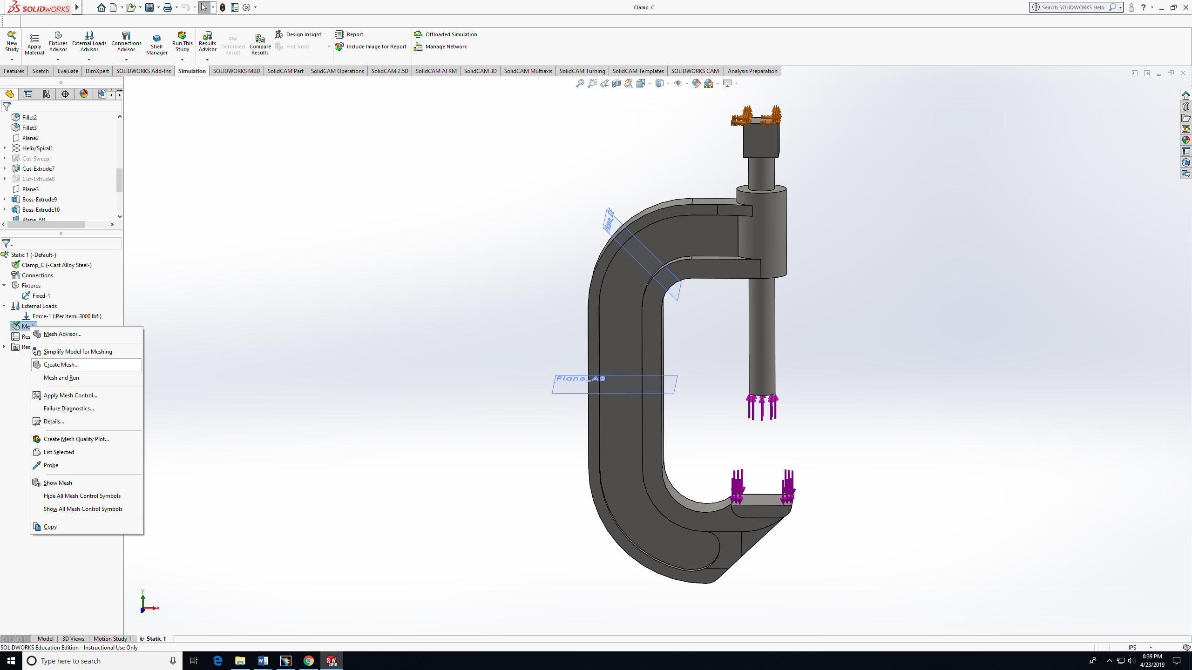

- Click on mesh parameter so you can choose the exact mesh size. Then ok.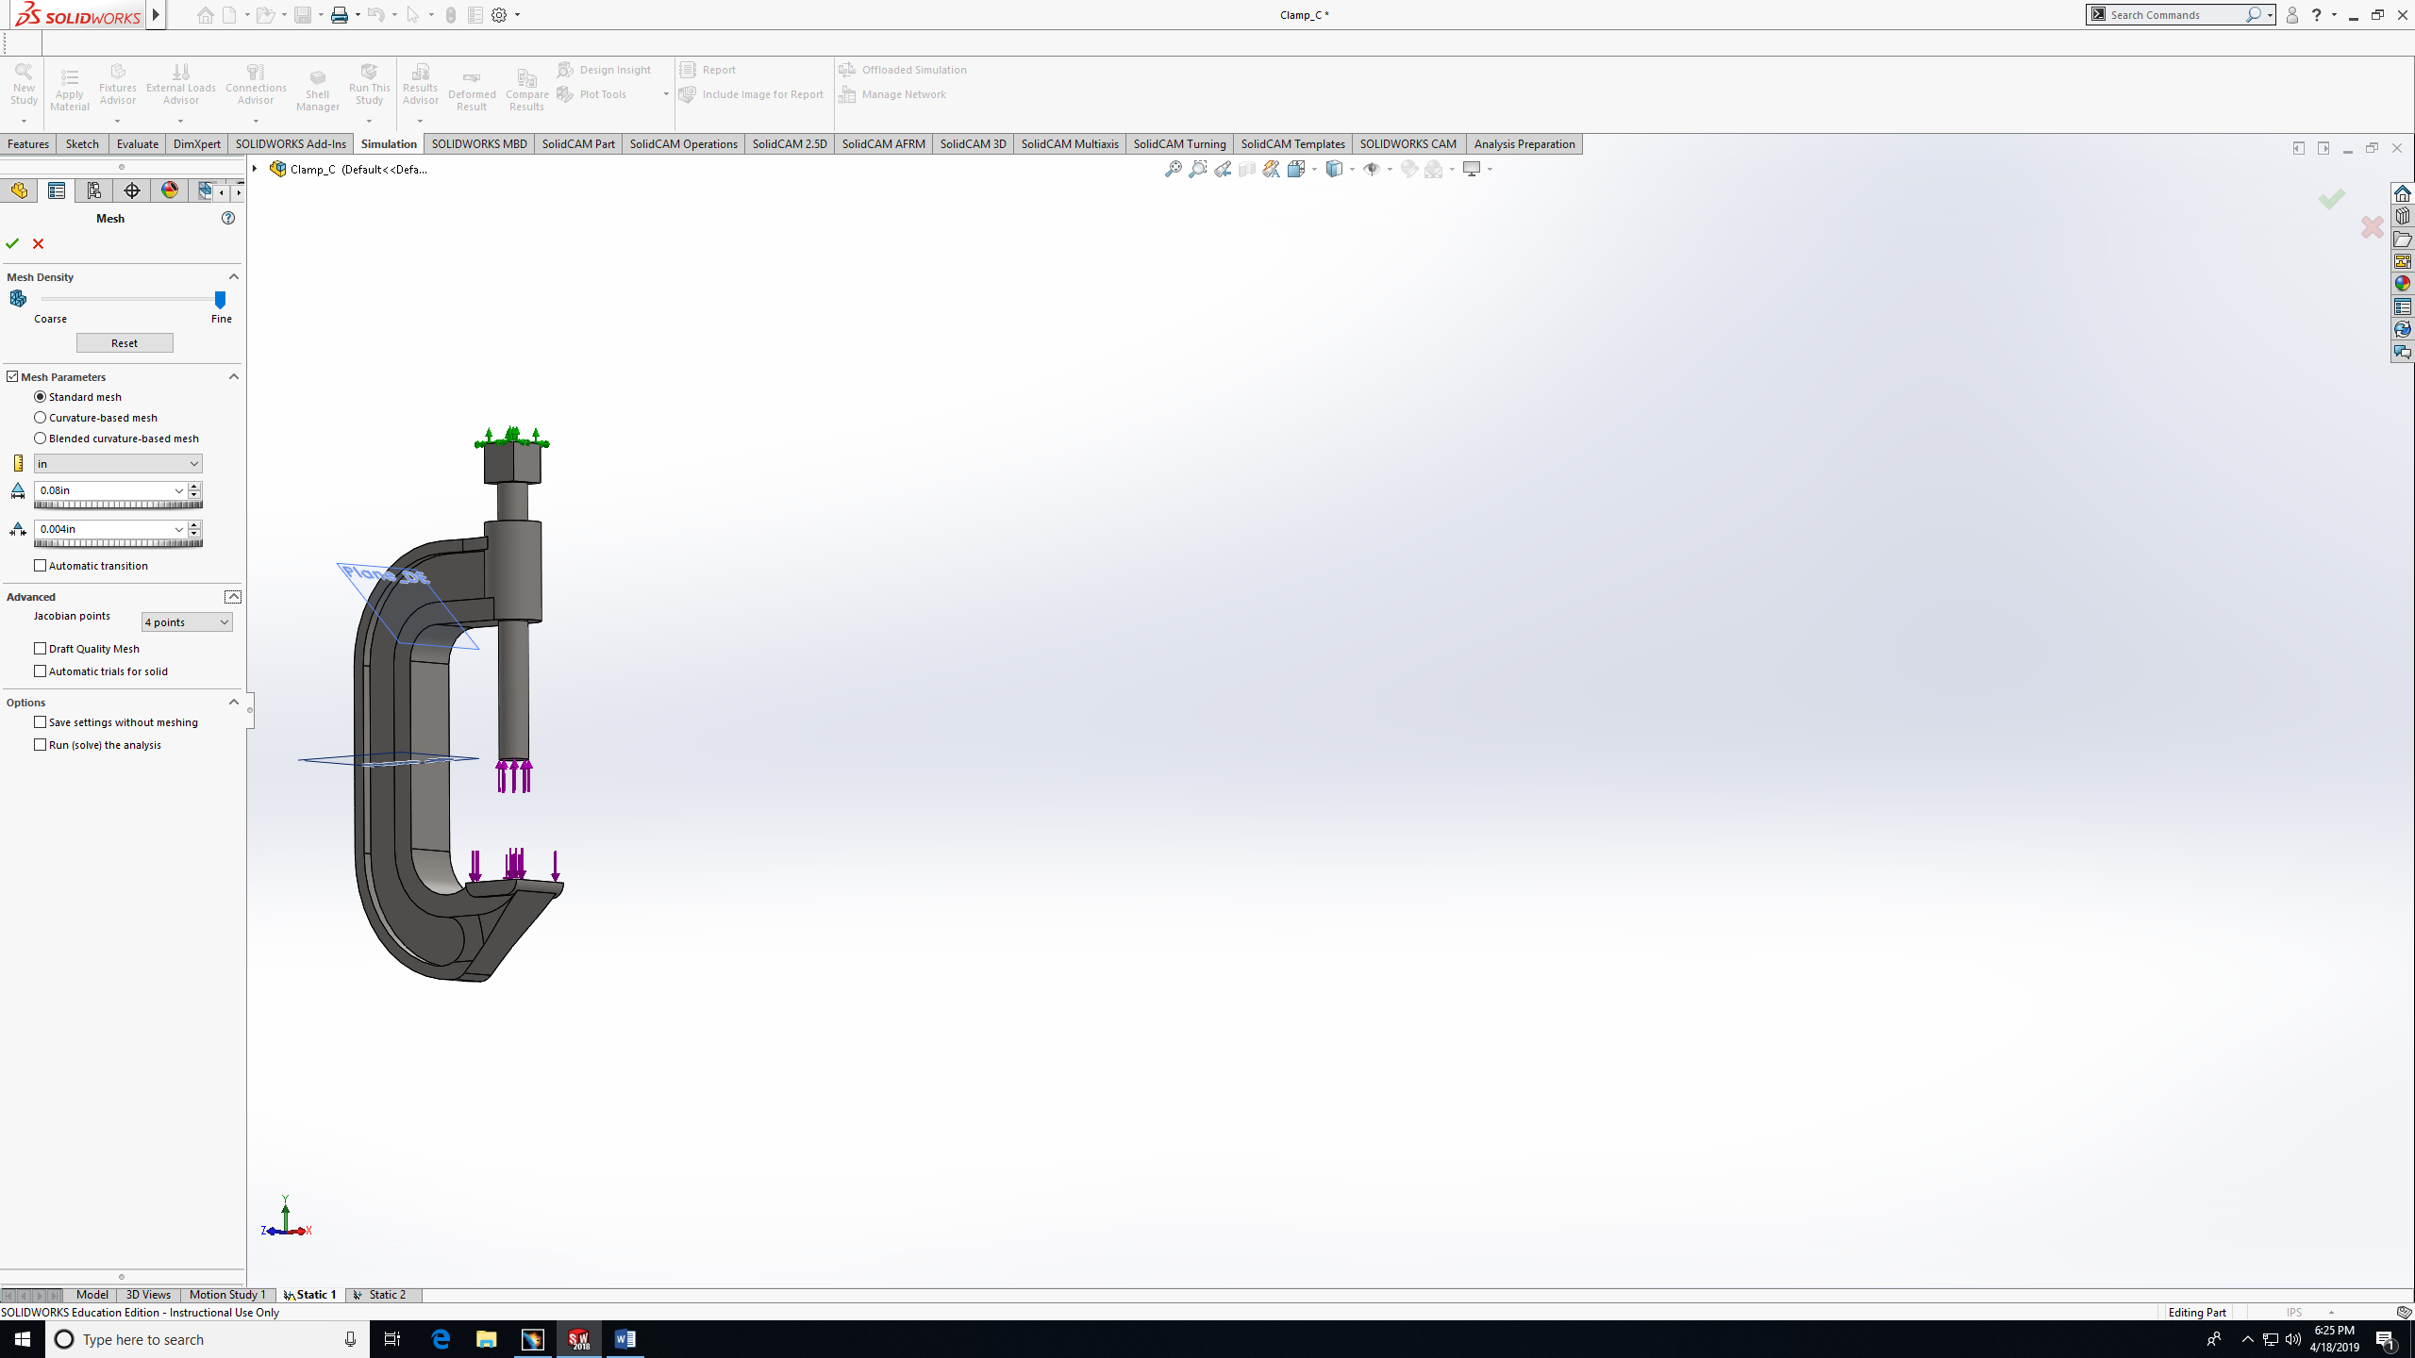
- Wait for the mesh to be calculated and applied.

- Mesh occurred, you can notice the model is being divided into small shapes (small meshes). 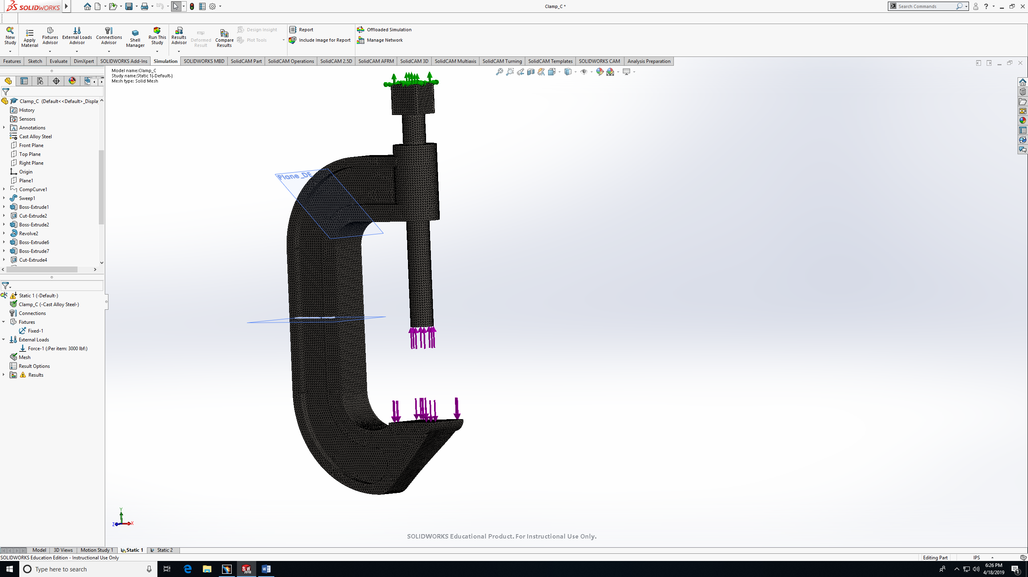
- Run the study.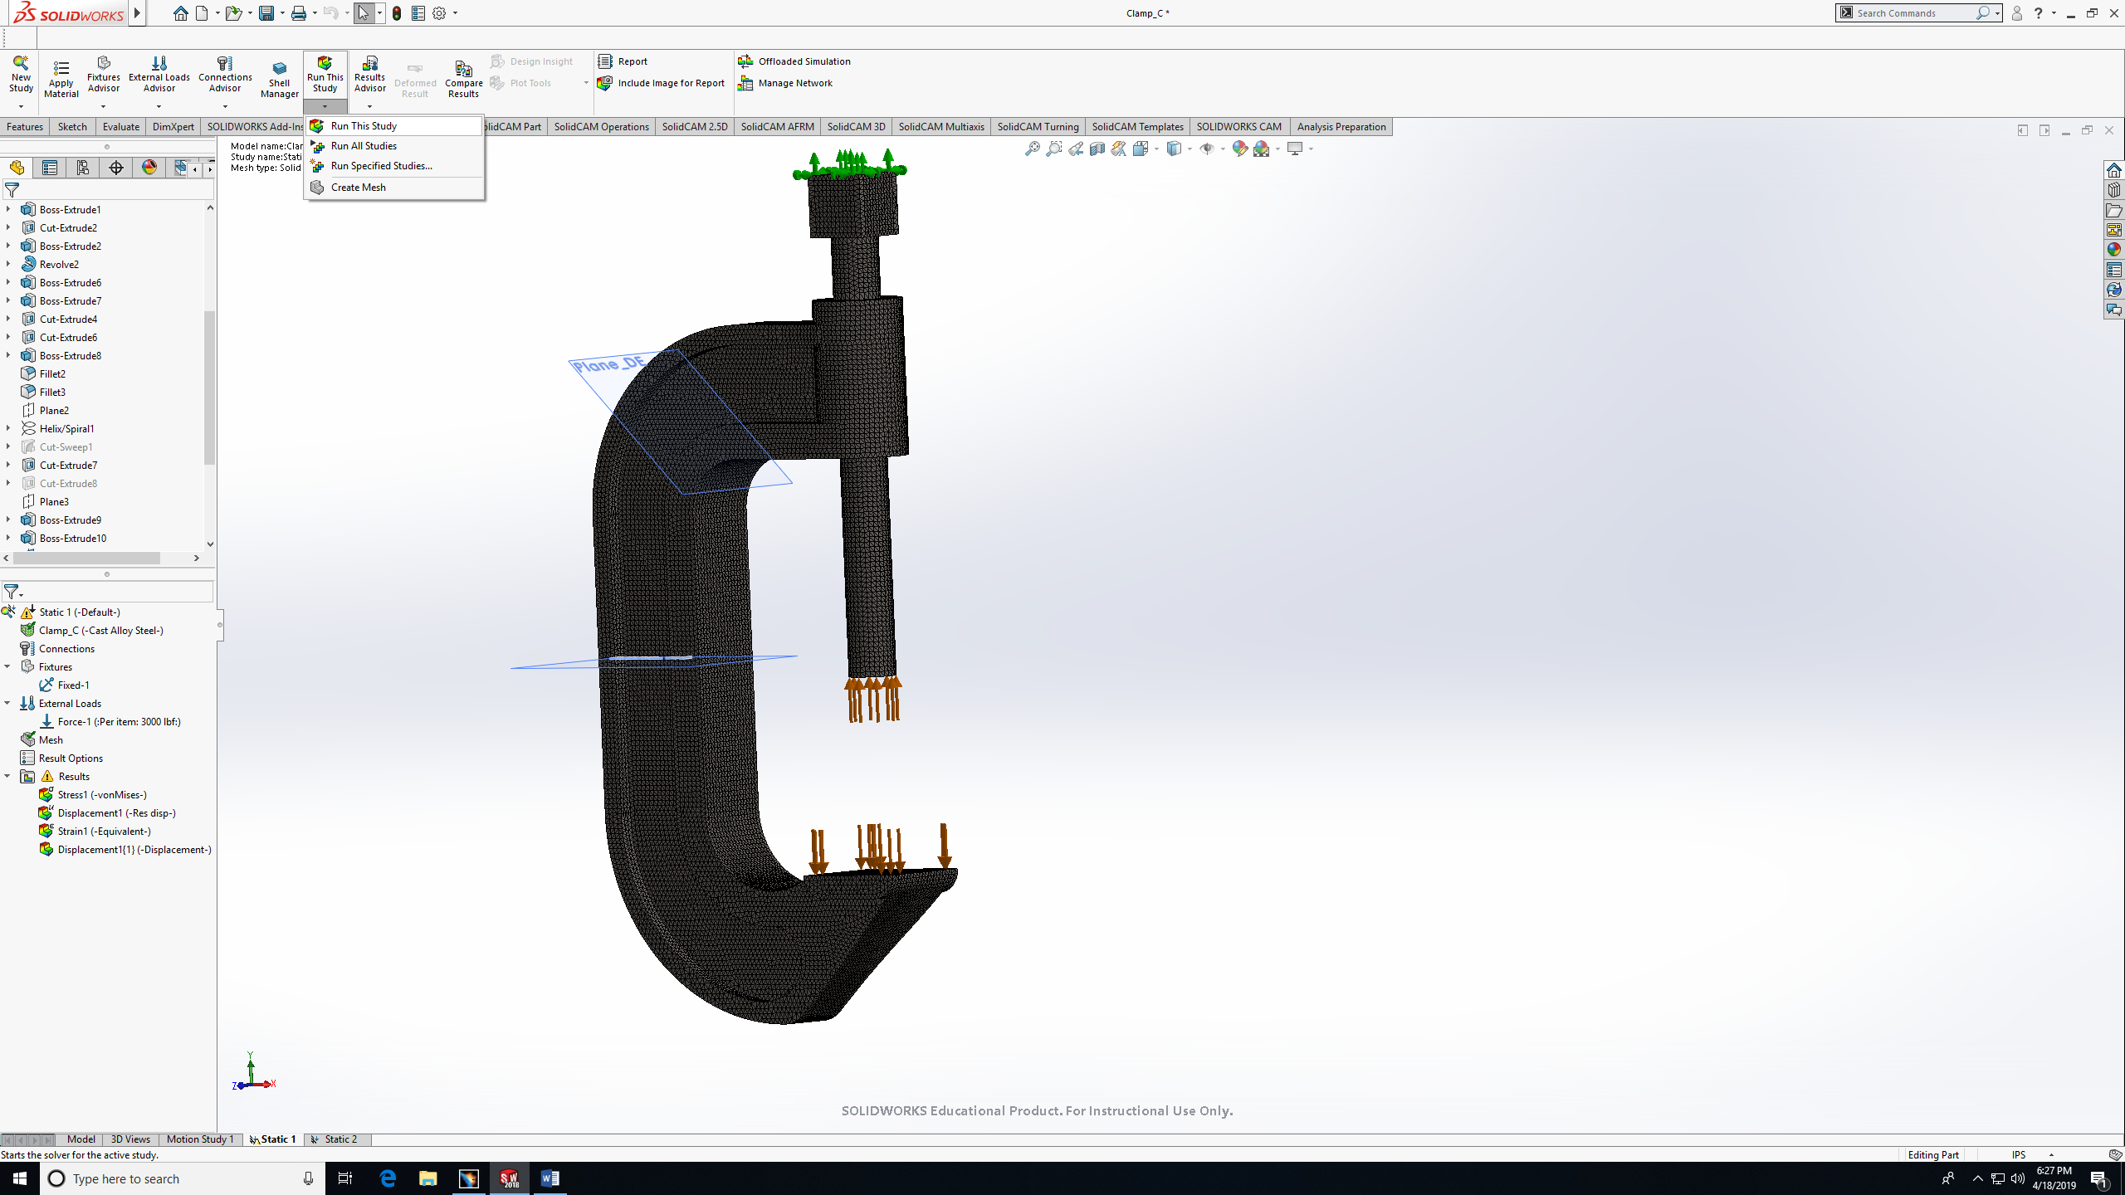

- Double-click in the table on the right to modify the study. Under display, chose VON.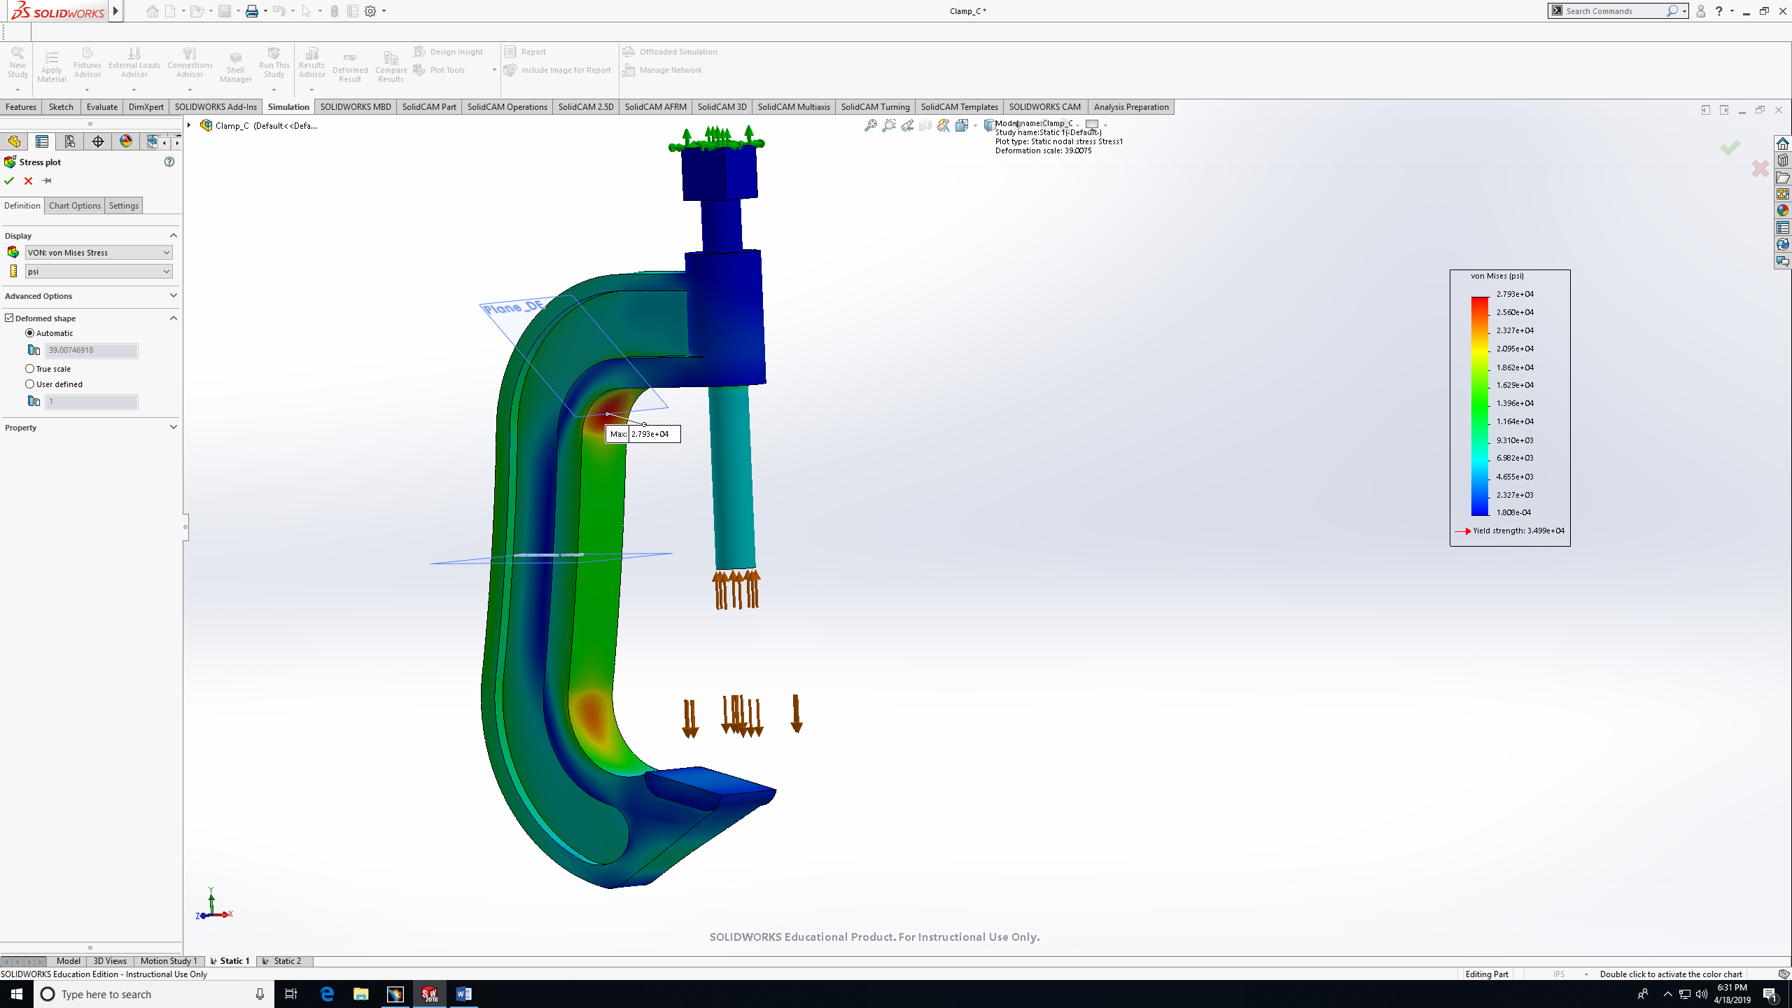
- For more details, click on chart option, then check Show max annotation, then Ok.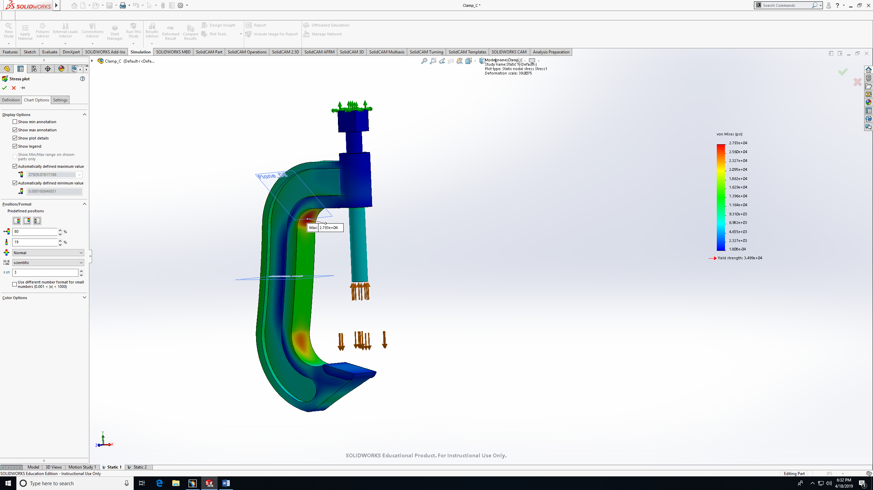
- Max stress shown as 27,930 psi in in the inner curve. It should be denoted that the max-stress occurs below the DE plane as the moment is greatest toward the bottom of the curved region “O”.
- To explore more stresses points, use the Probe feature. 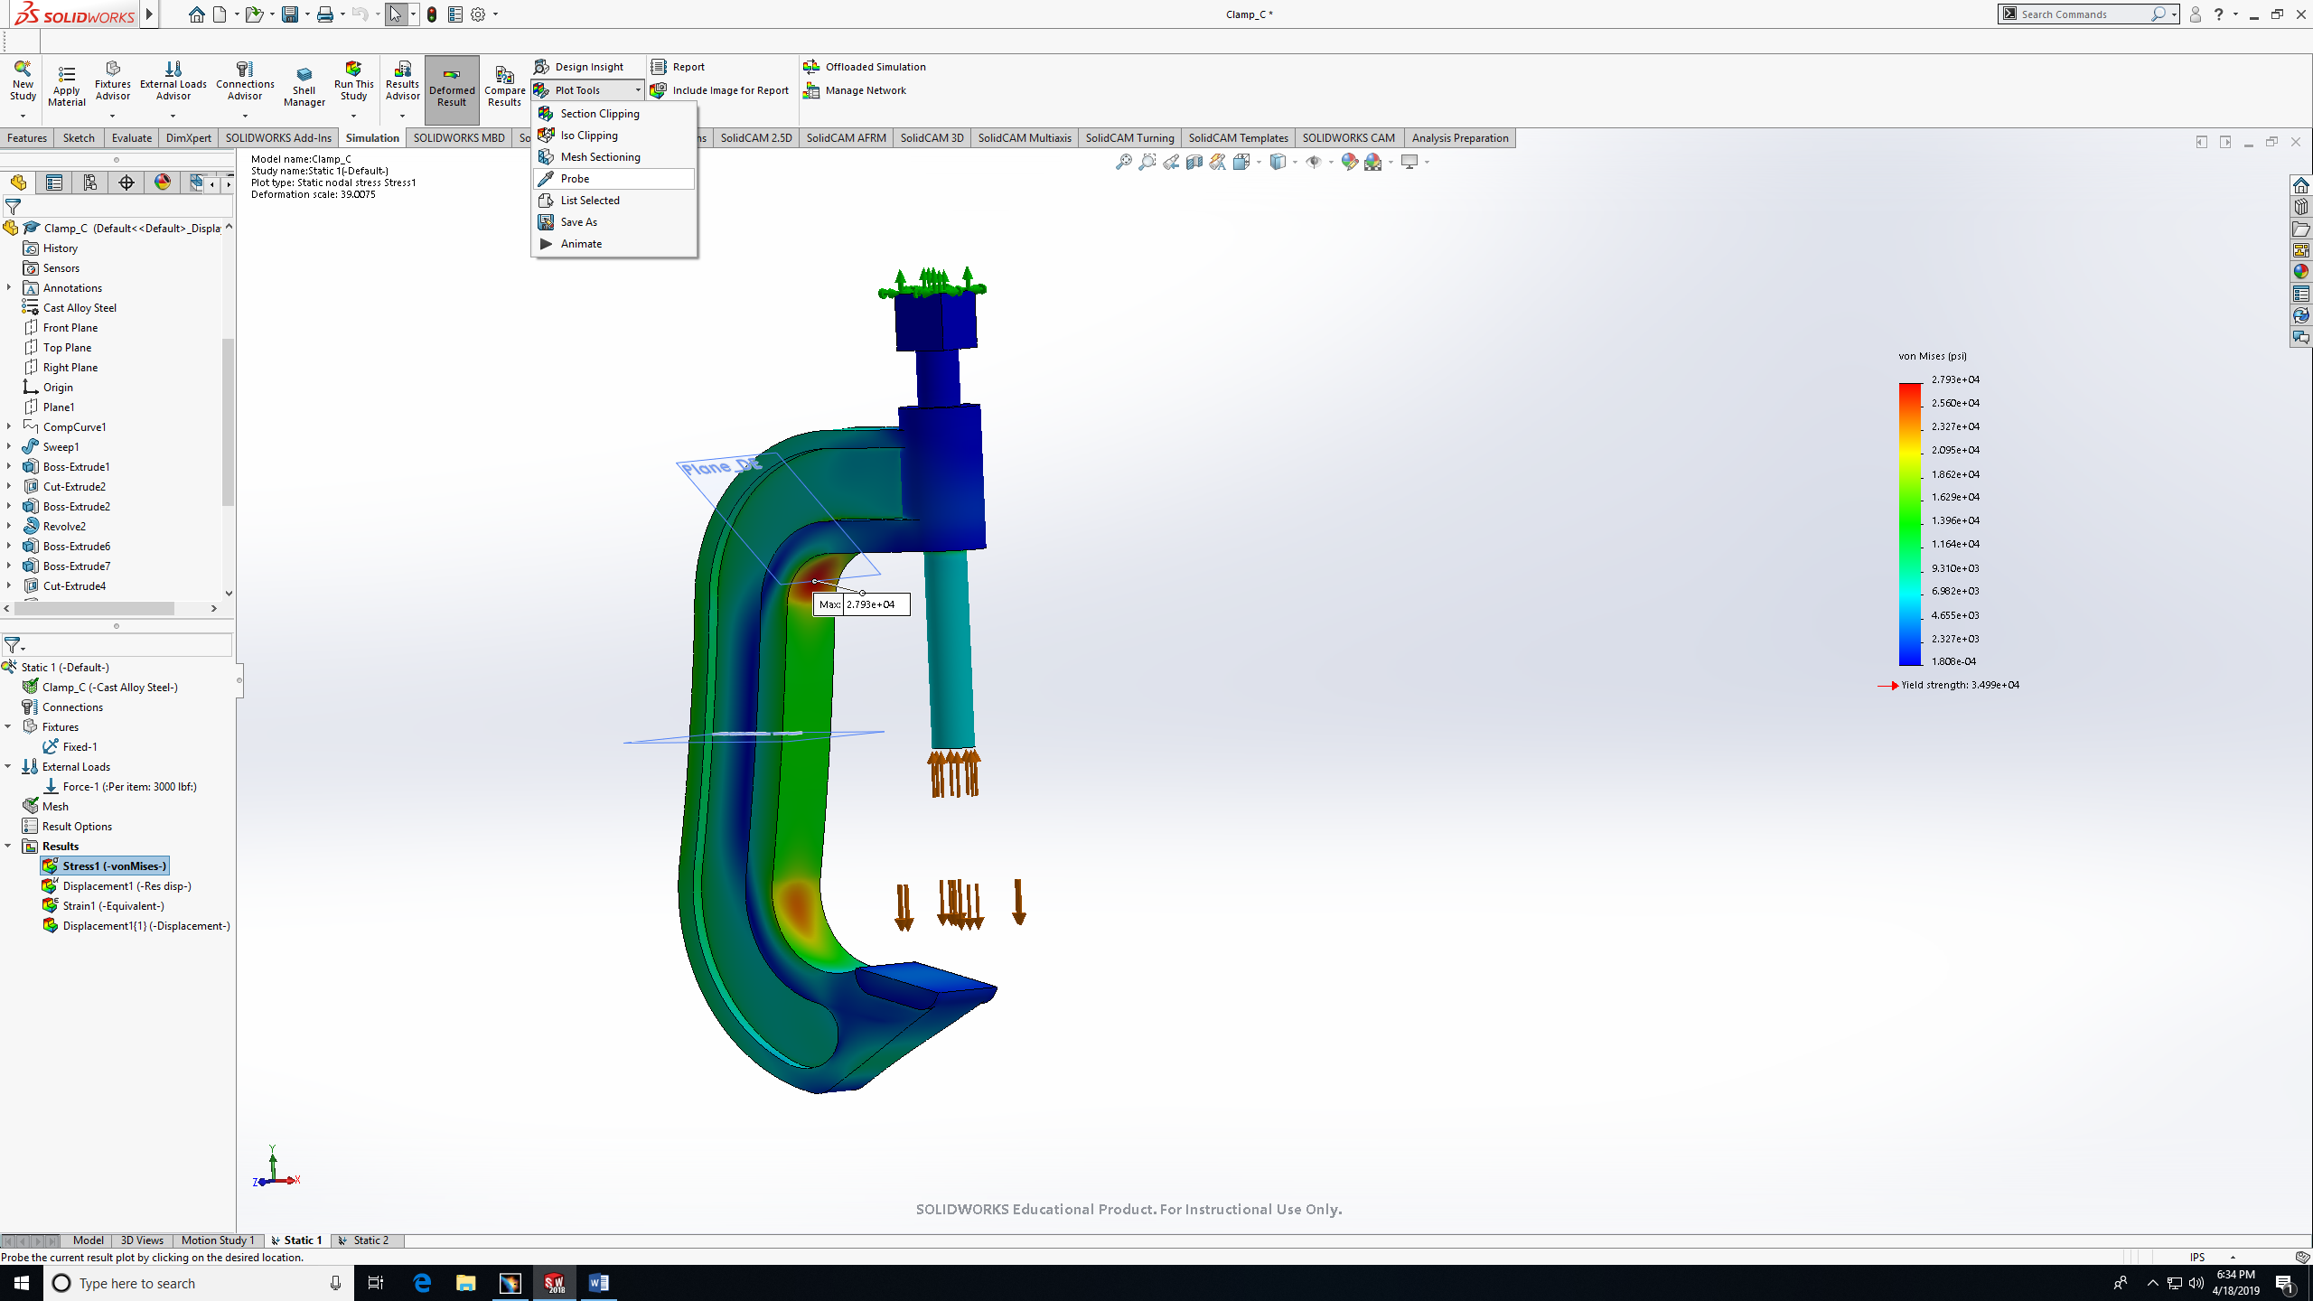

- Choose location where you want to see the stress value.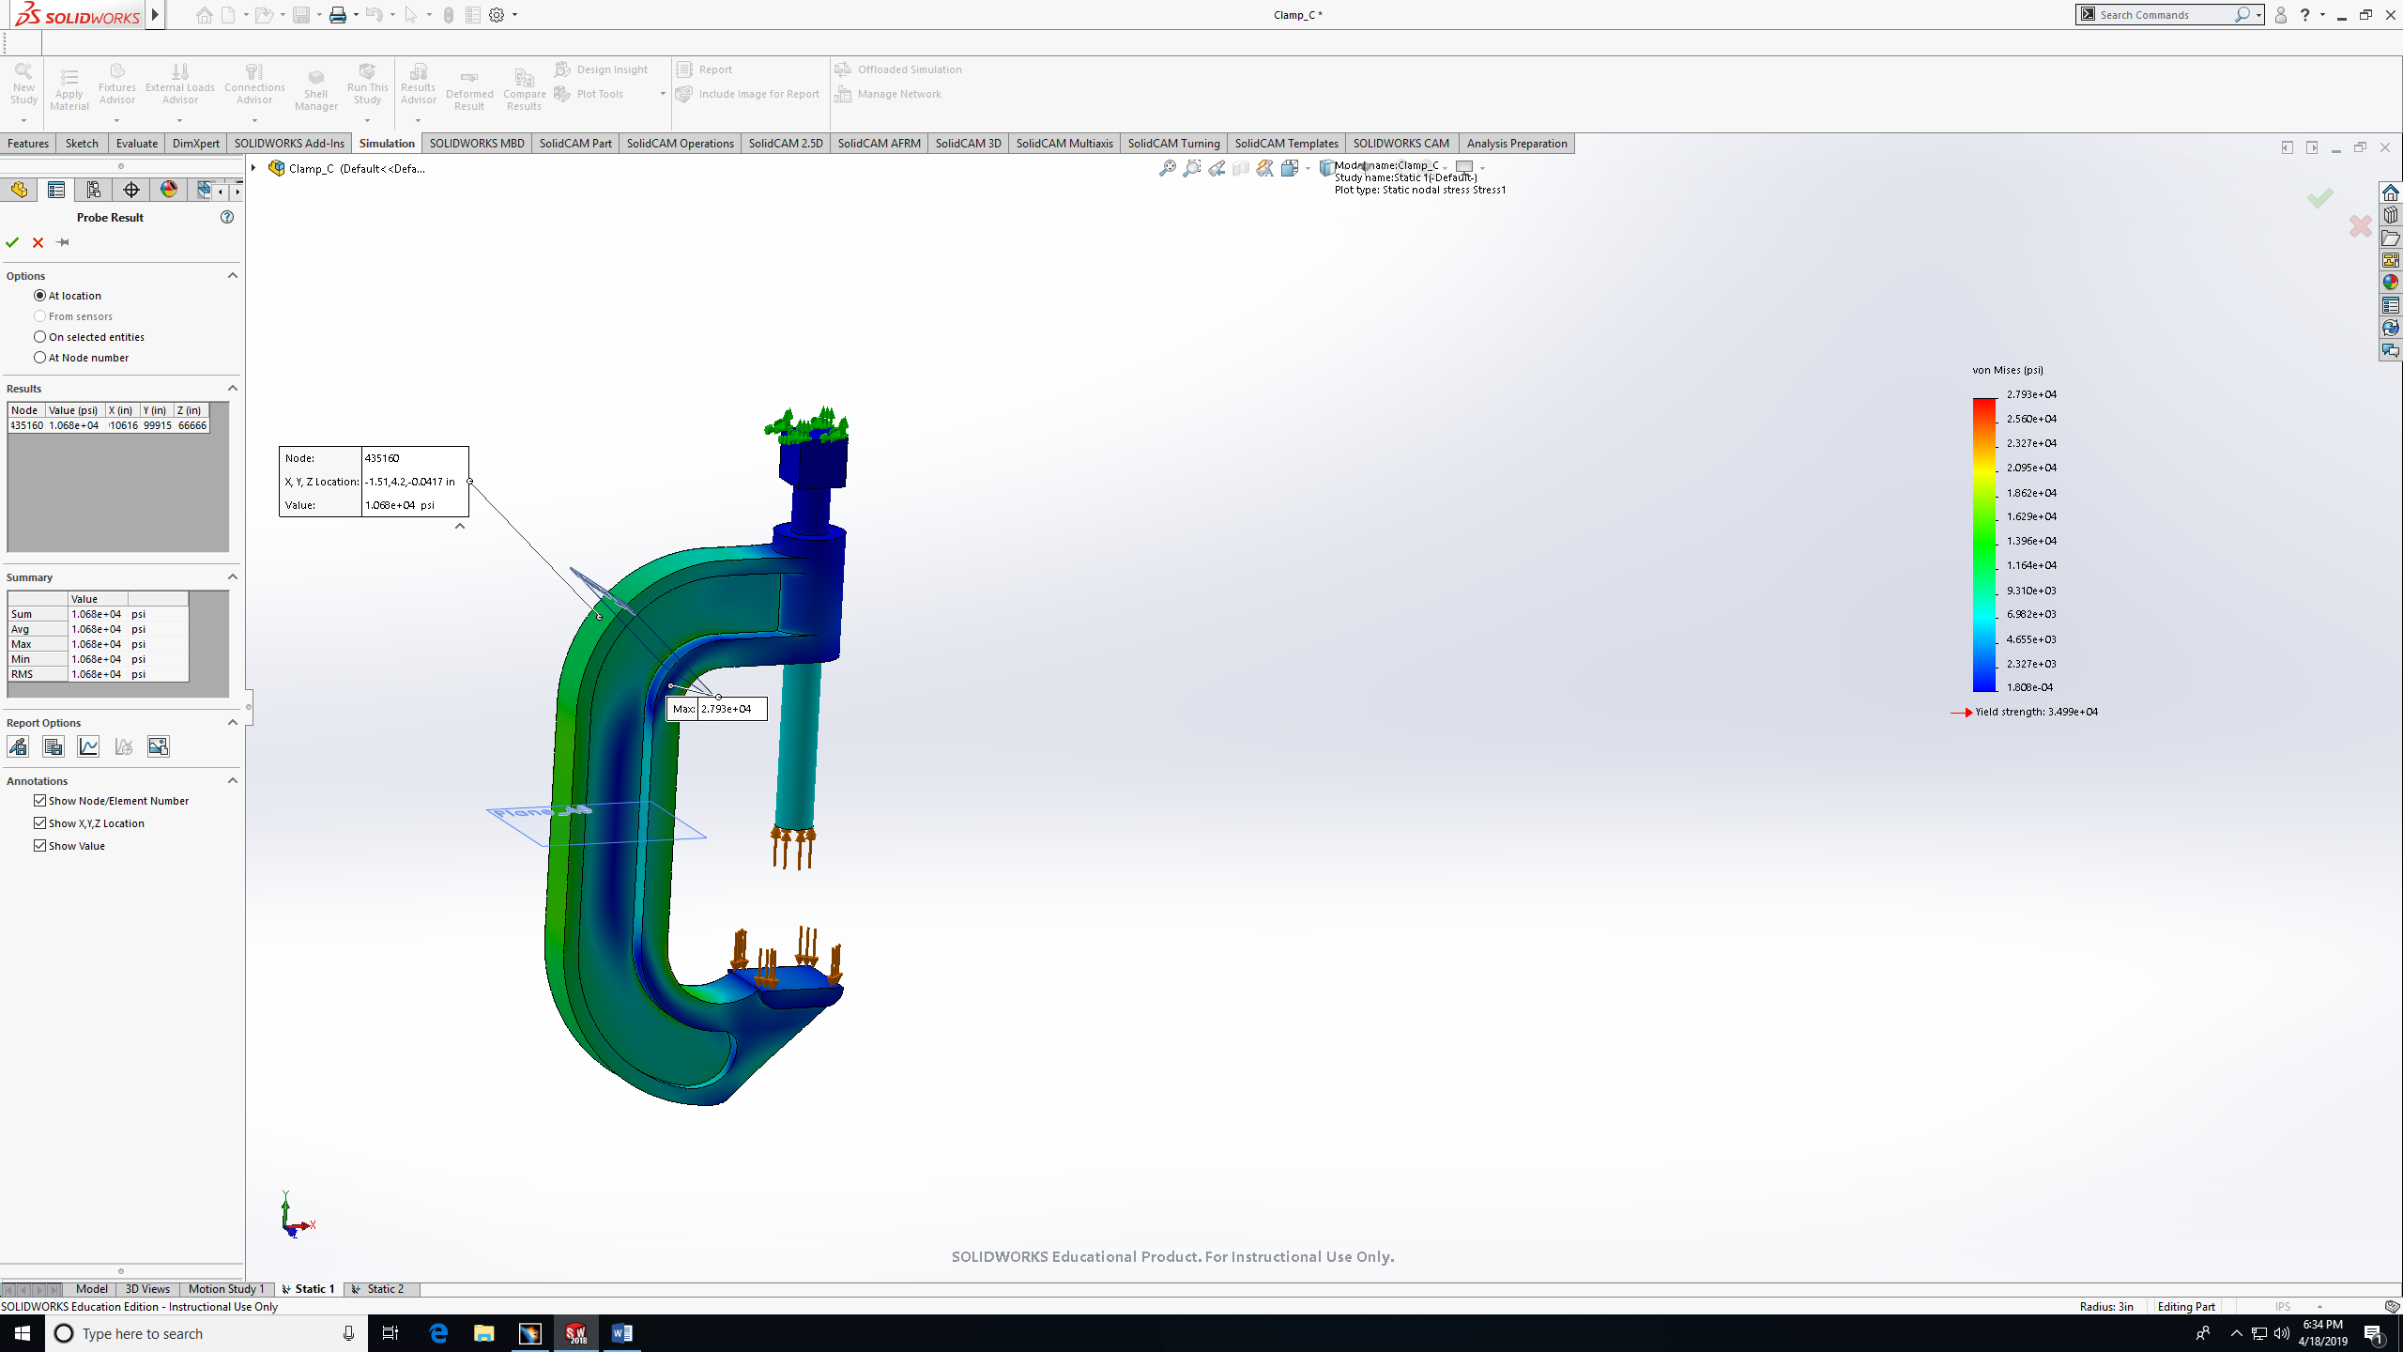
- You can choose more than one point. All the result will appear in the schedule on the left 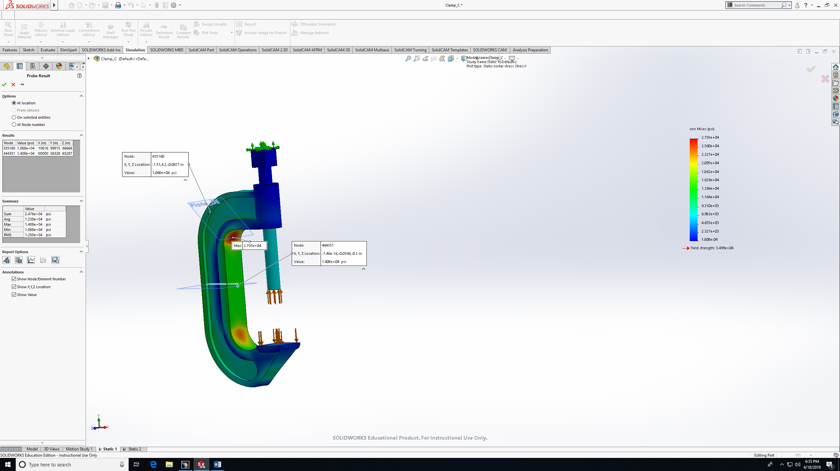

- The picture below shows the approach to the results by taking several points on a specific plane and find the largest between them:
- AB Inner Surface Max stress values 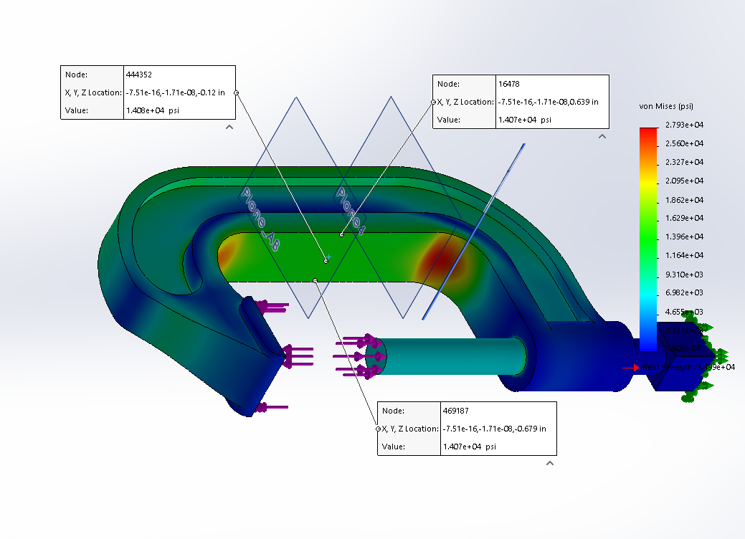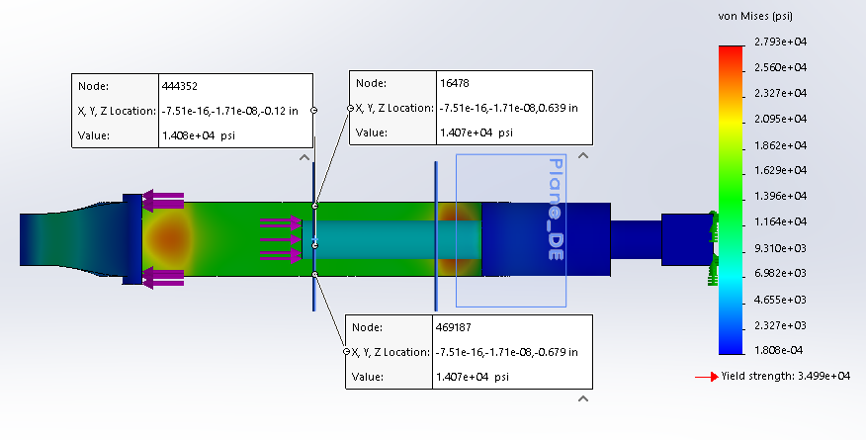
- AB Outer Surface Max stress 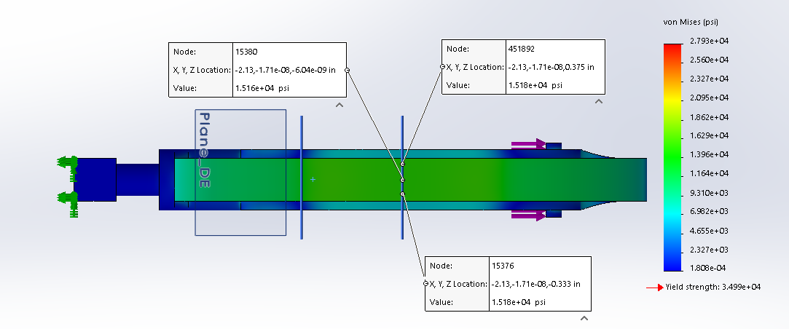
- DE Inner Surface Max stress
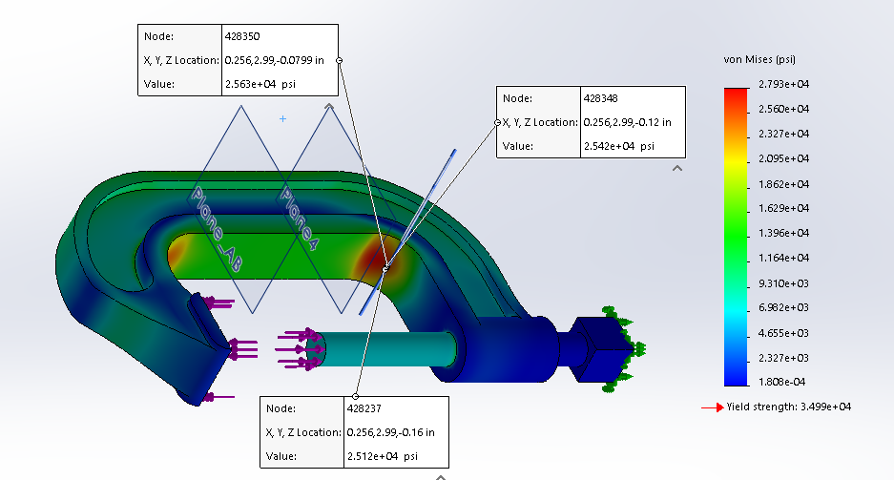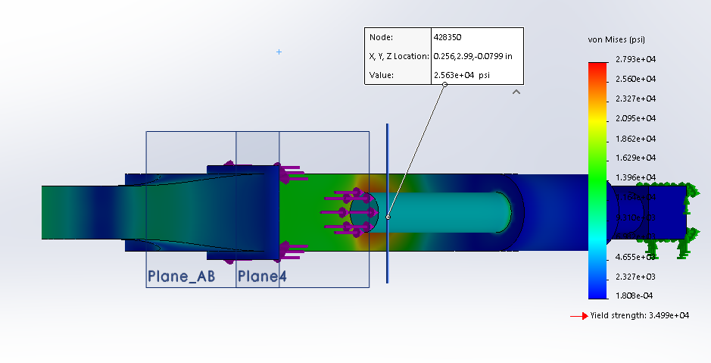
- DE Outer Surface Max stress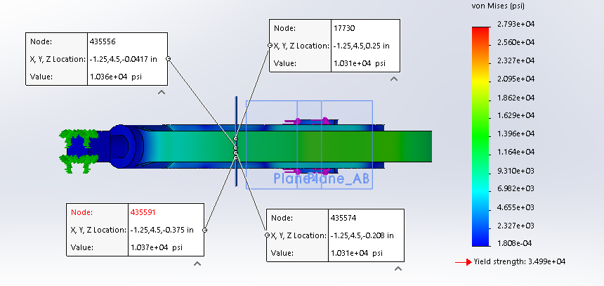

Using CATIA
After opening the model part in CATIA:
- Go to start, then analysis and simulation. Click on generative structural analysis. 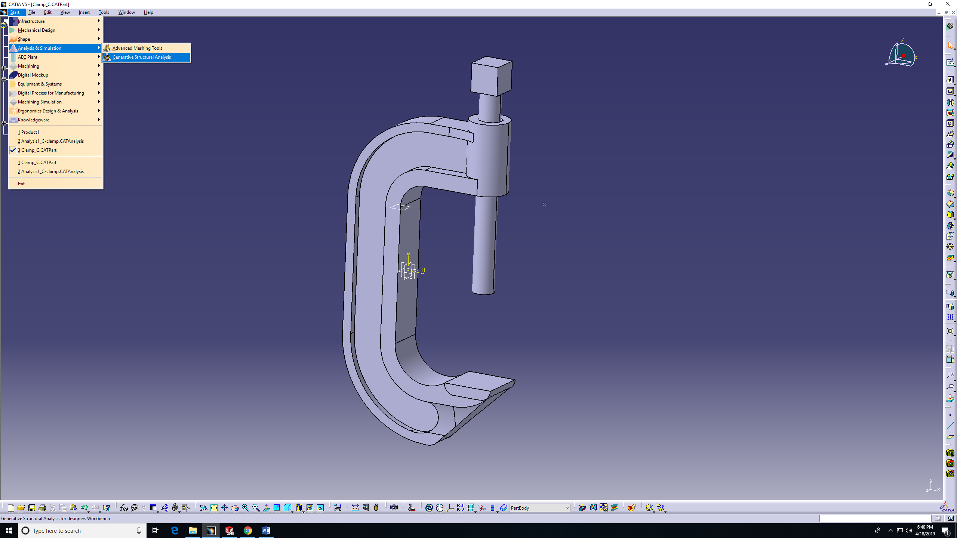
- Choose static analysis, then OK.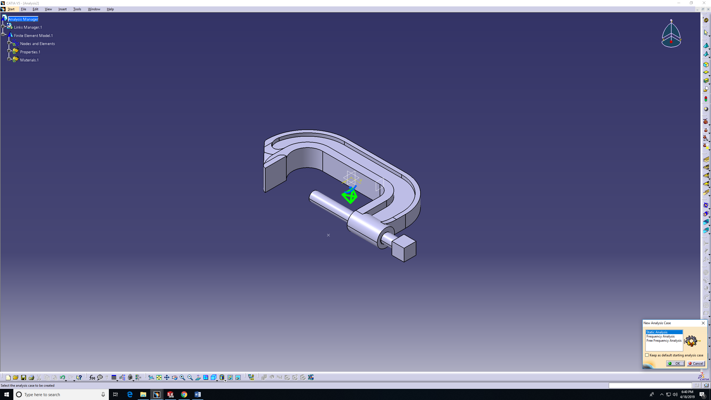

- Feature shows in the tree. Statics Study is now avilable. Now you can apply nodes and elements. Under statics case you can apply load and fixture.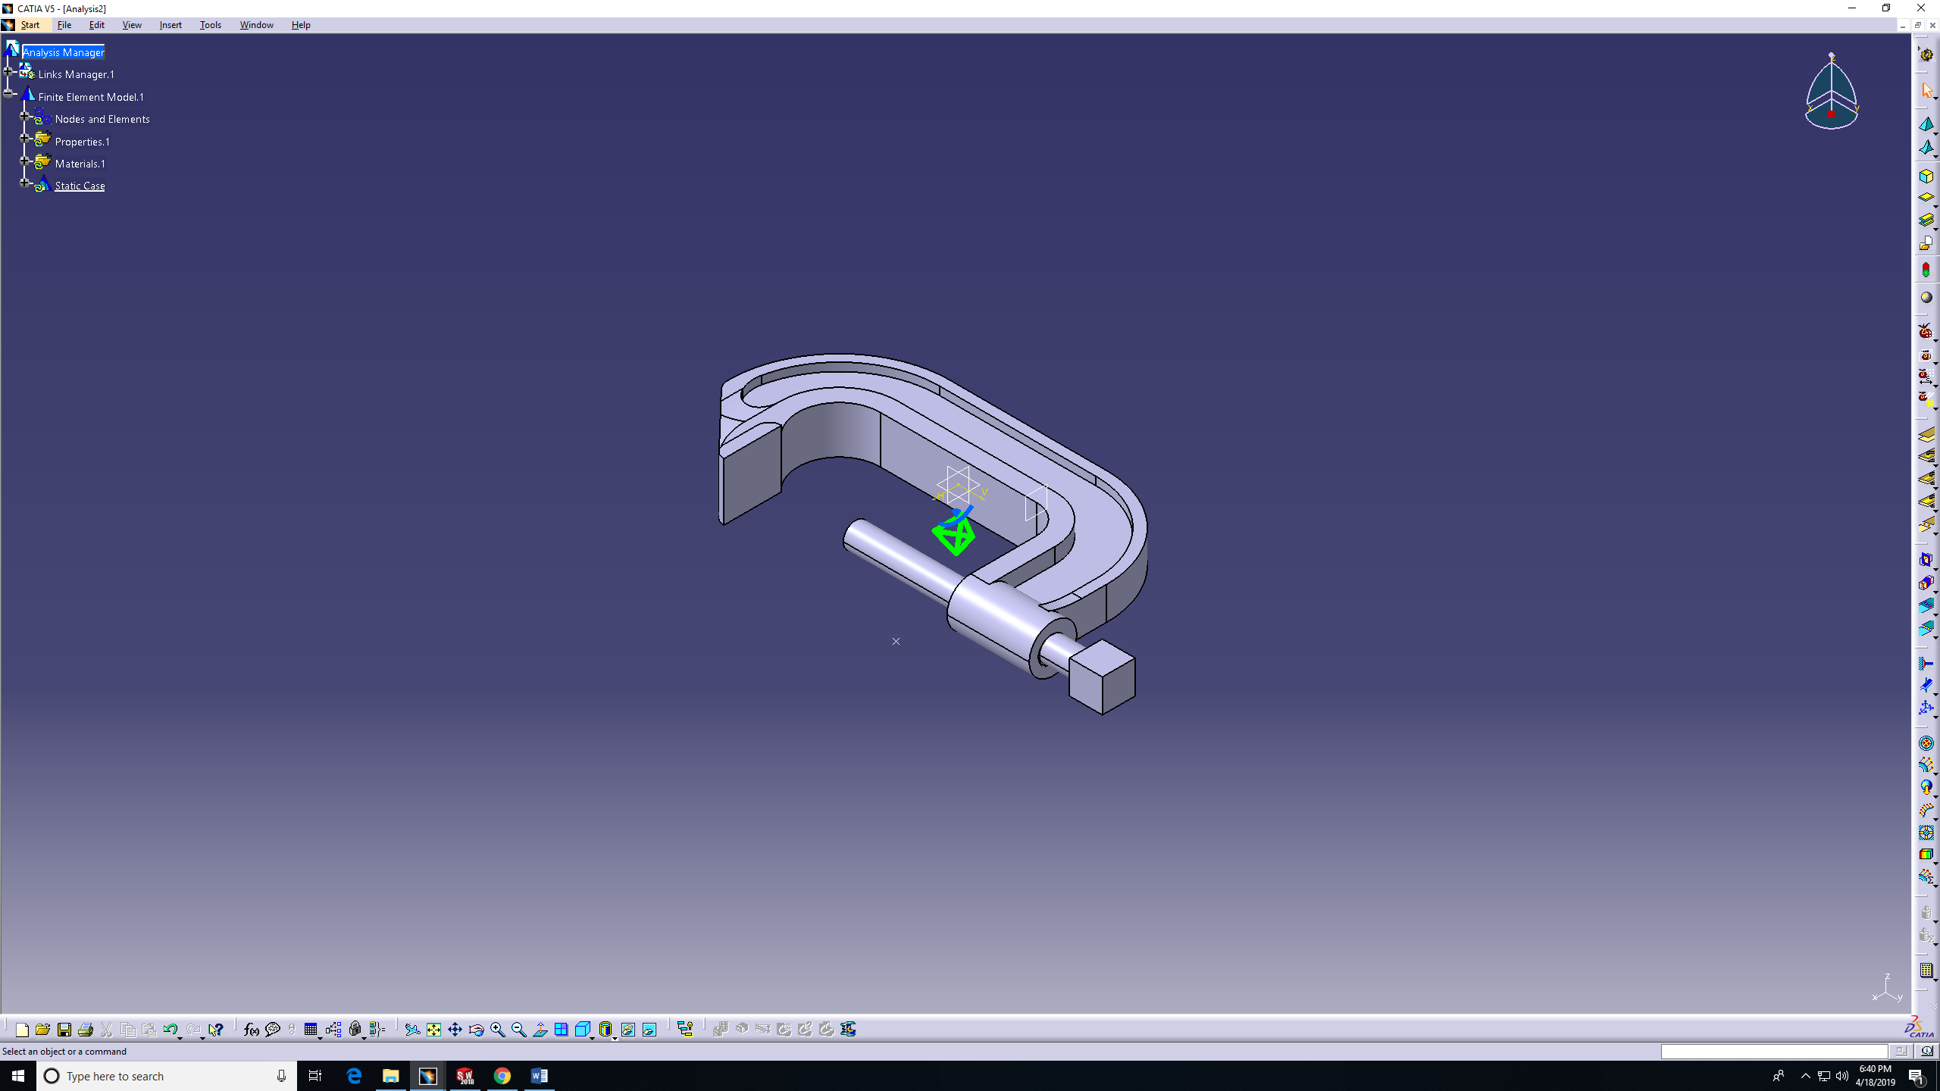
- Open nodes and elements. Then double click on OCTREE Tetrahedron Mesh1, choose the mesh size using the box showed on the bottom right corner. 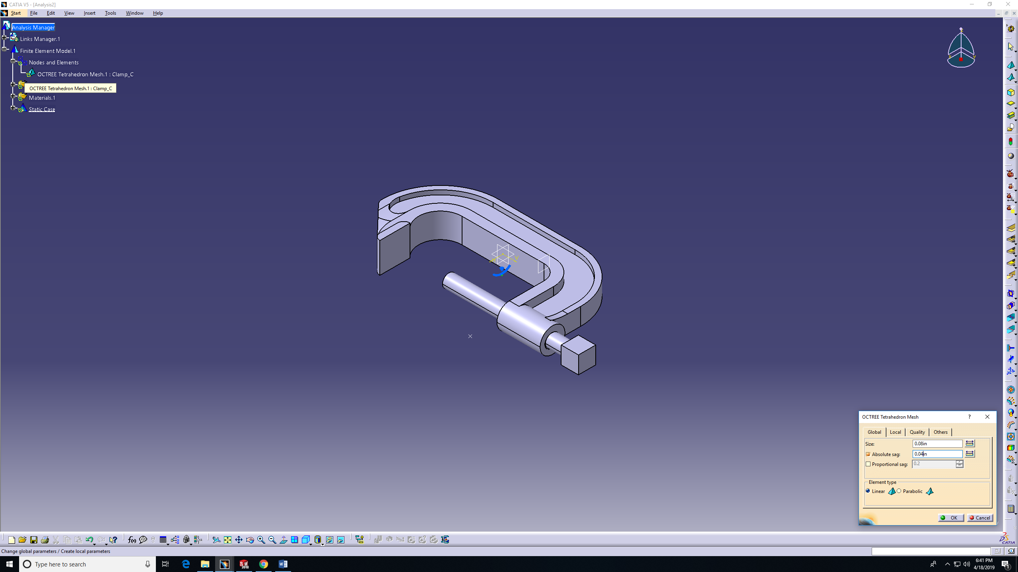

- Double click on compute to start creating the mesh. Then choose all, then OK. All tools drops may not be visible in the right-hand tools. If needed, drag and drop more tools into view point. 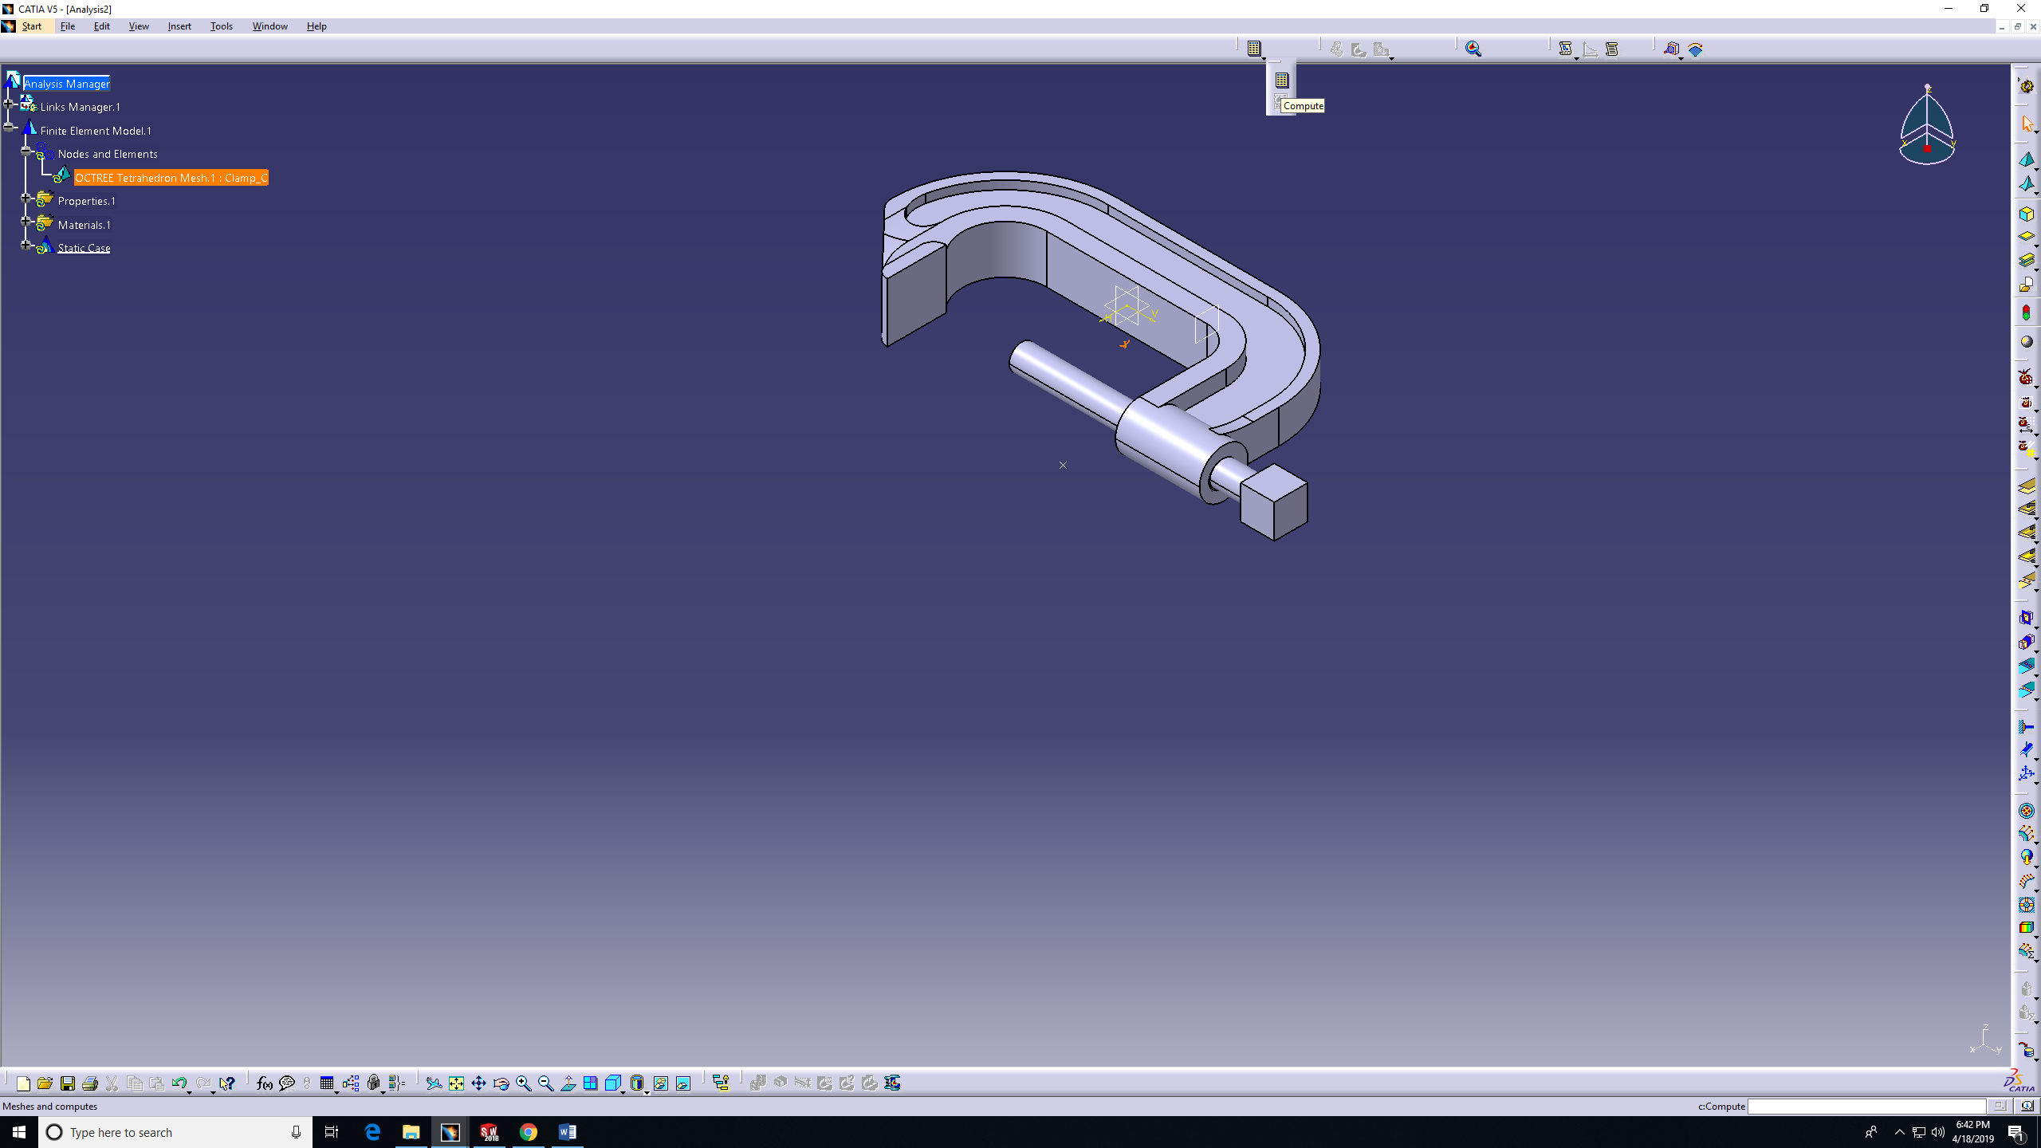
- For computation resources estimation click yes. wait for calculation of the mesh. If estimation analysis box shows press OK. 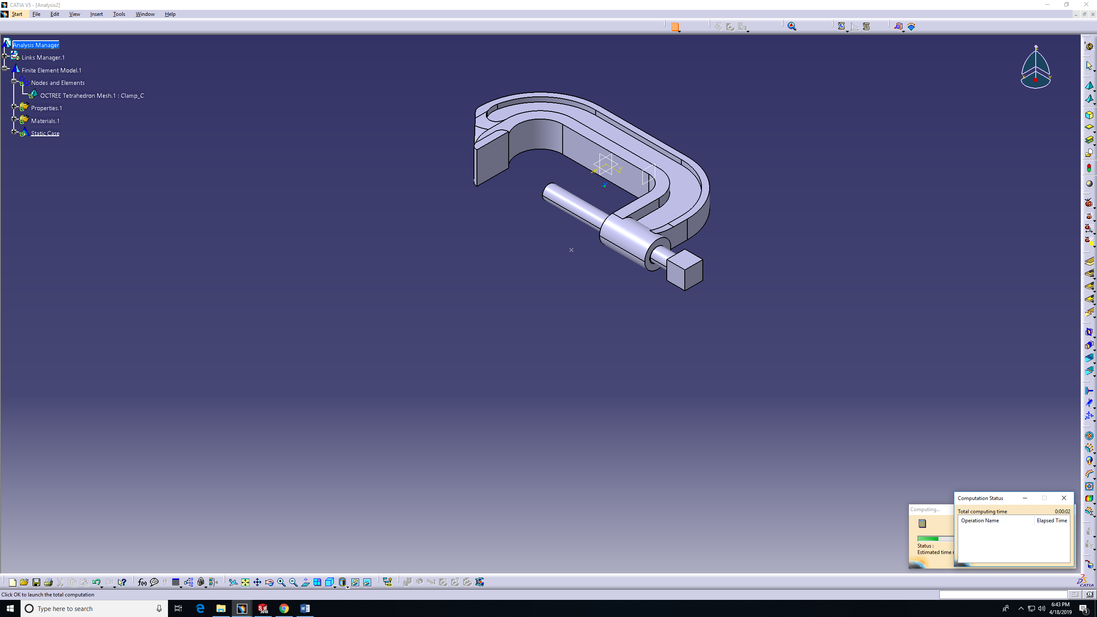

- Add clamp as the fixture under the restraint feature on the tree or on CATIA features. 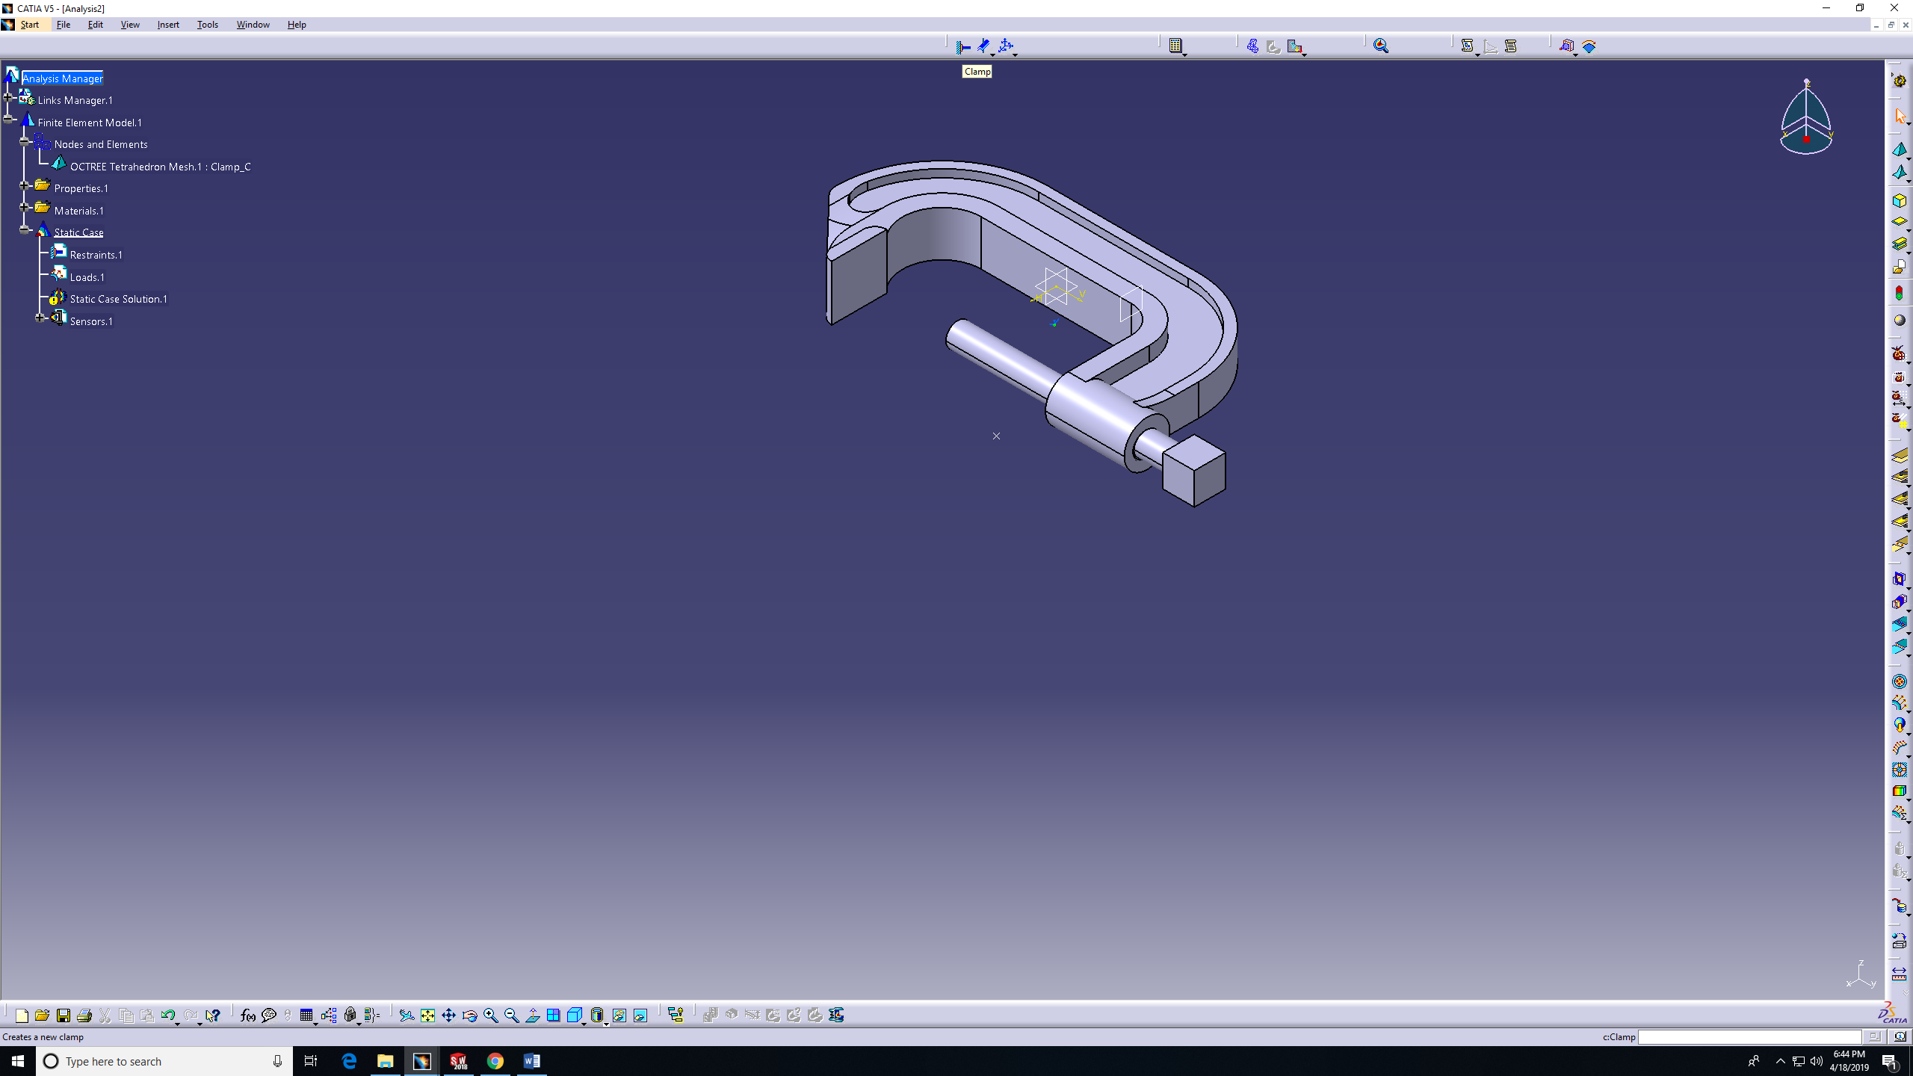
- Choose the face to be the fixed face. Then OK. 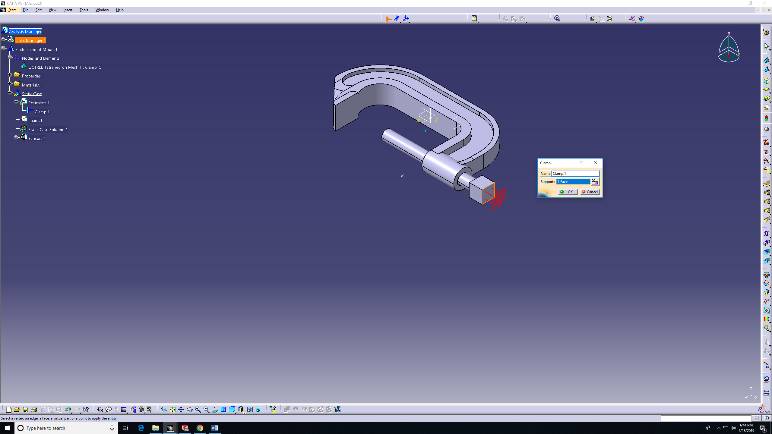

- Add a distributed force under the load feature on the tree or on CATIA features. 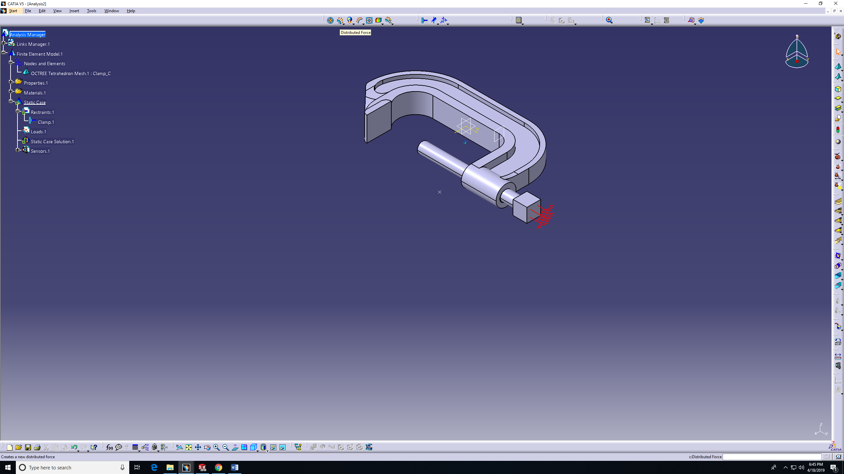
- To add the first load, choose the face, force value, and direction. Then OK. (Add -ve sign for opposite direction)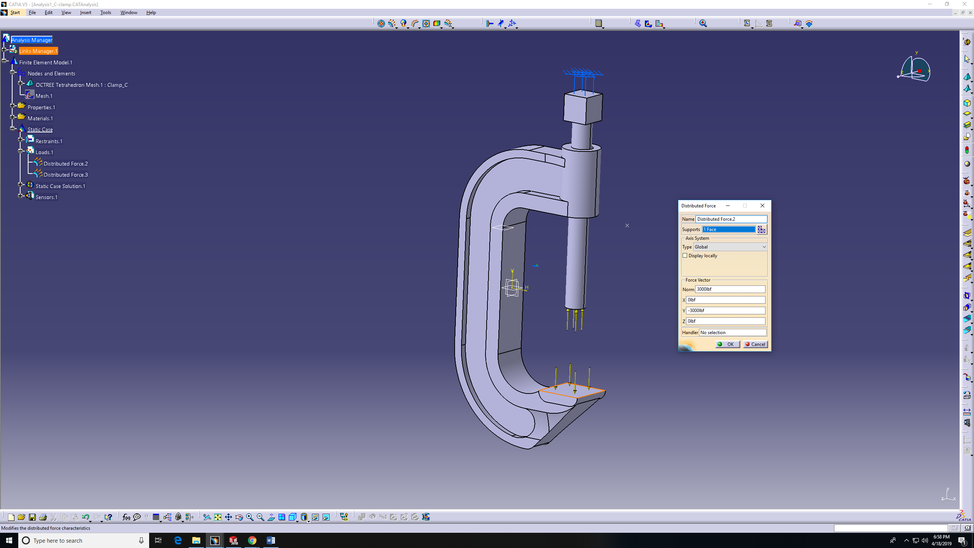

- Add the other force, similar to step 10. 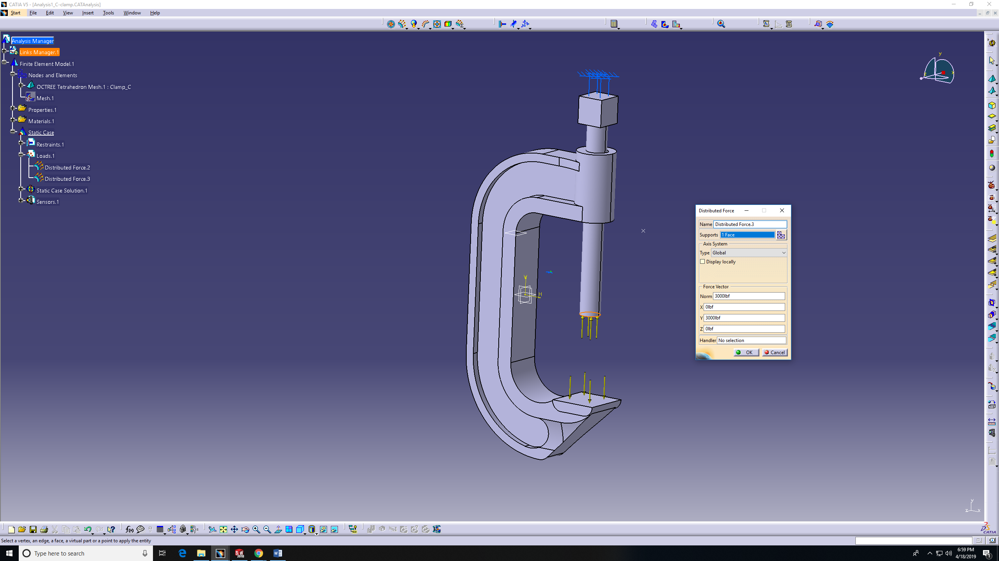

NOTE: In CATIA, it’s done in two steps since the direction is different. CATIA recognizes the of force direction by the sign of the force value. This is why we added (-ve) on the first.

- Apply Von-Mises study on the model. 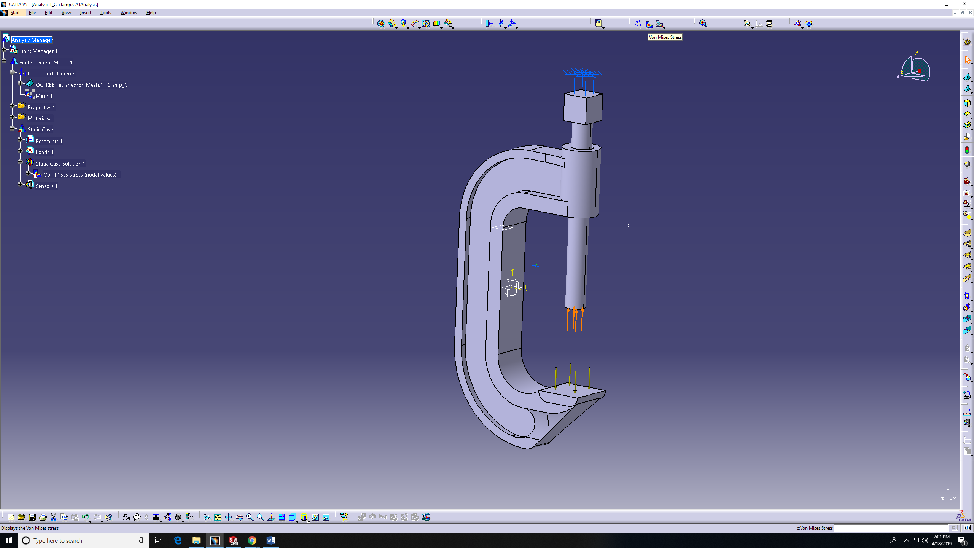
- Von-Mises feature applied. 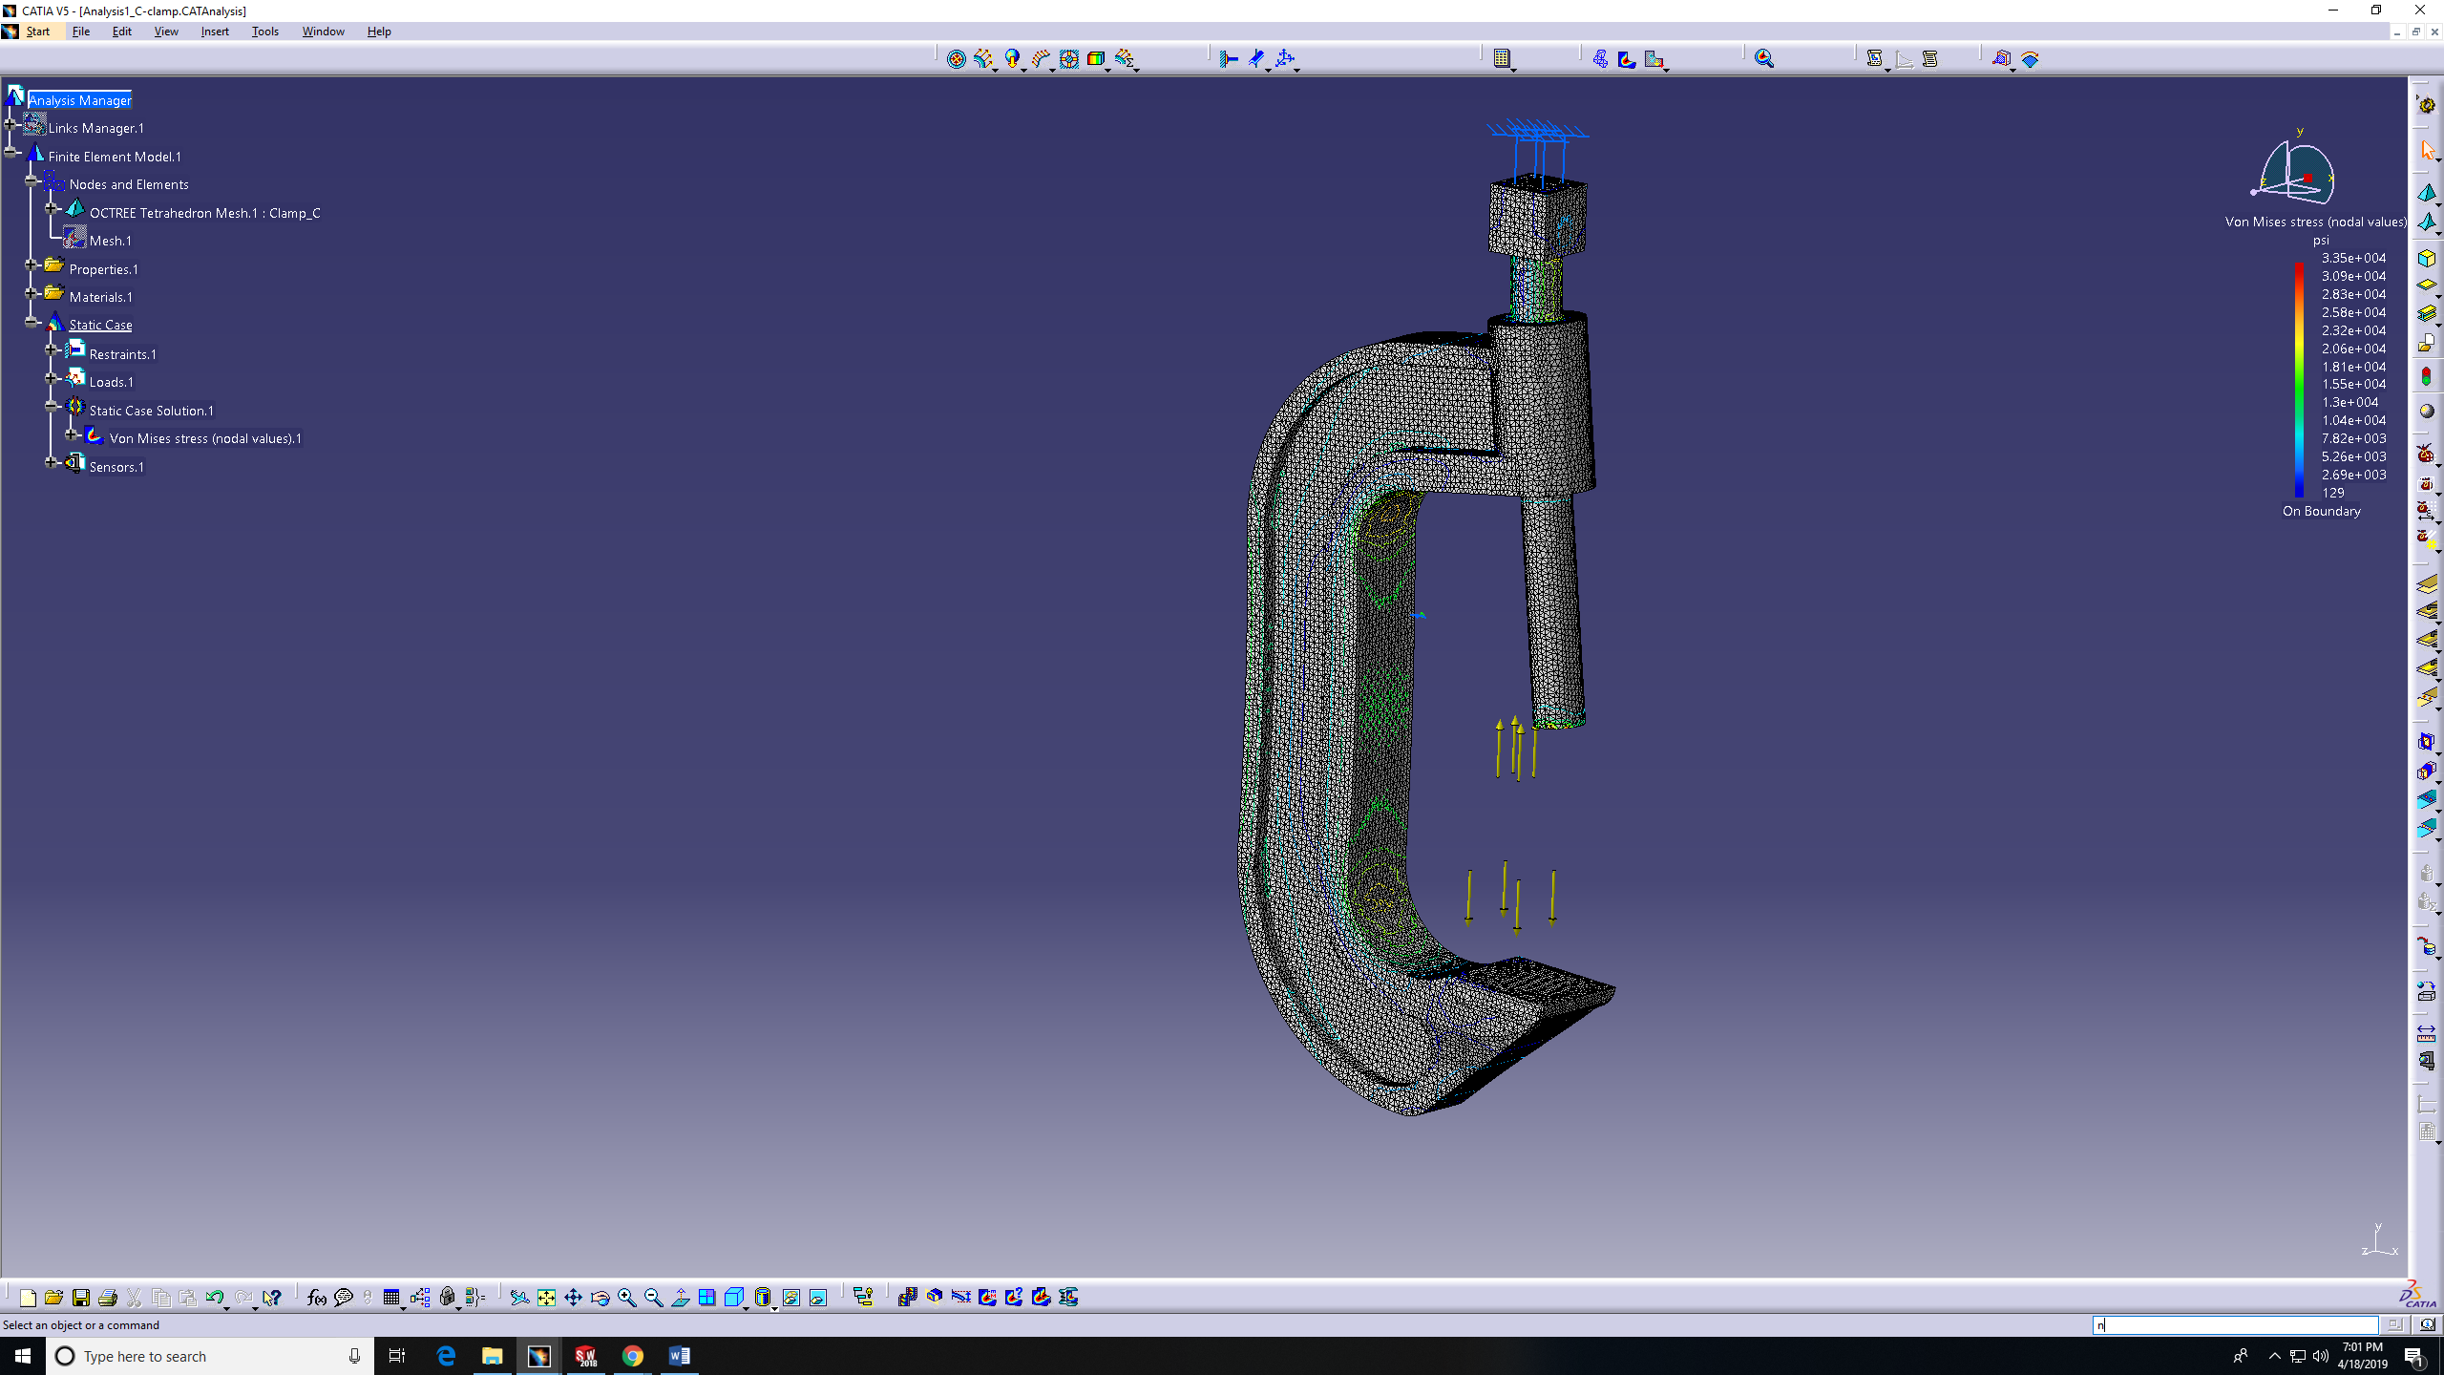

- Planes AB and DE need to be created to help finding the stresses values in required locations. 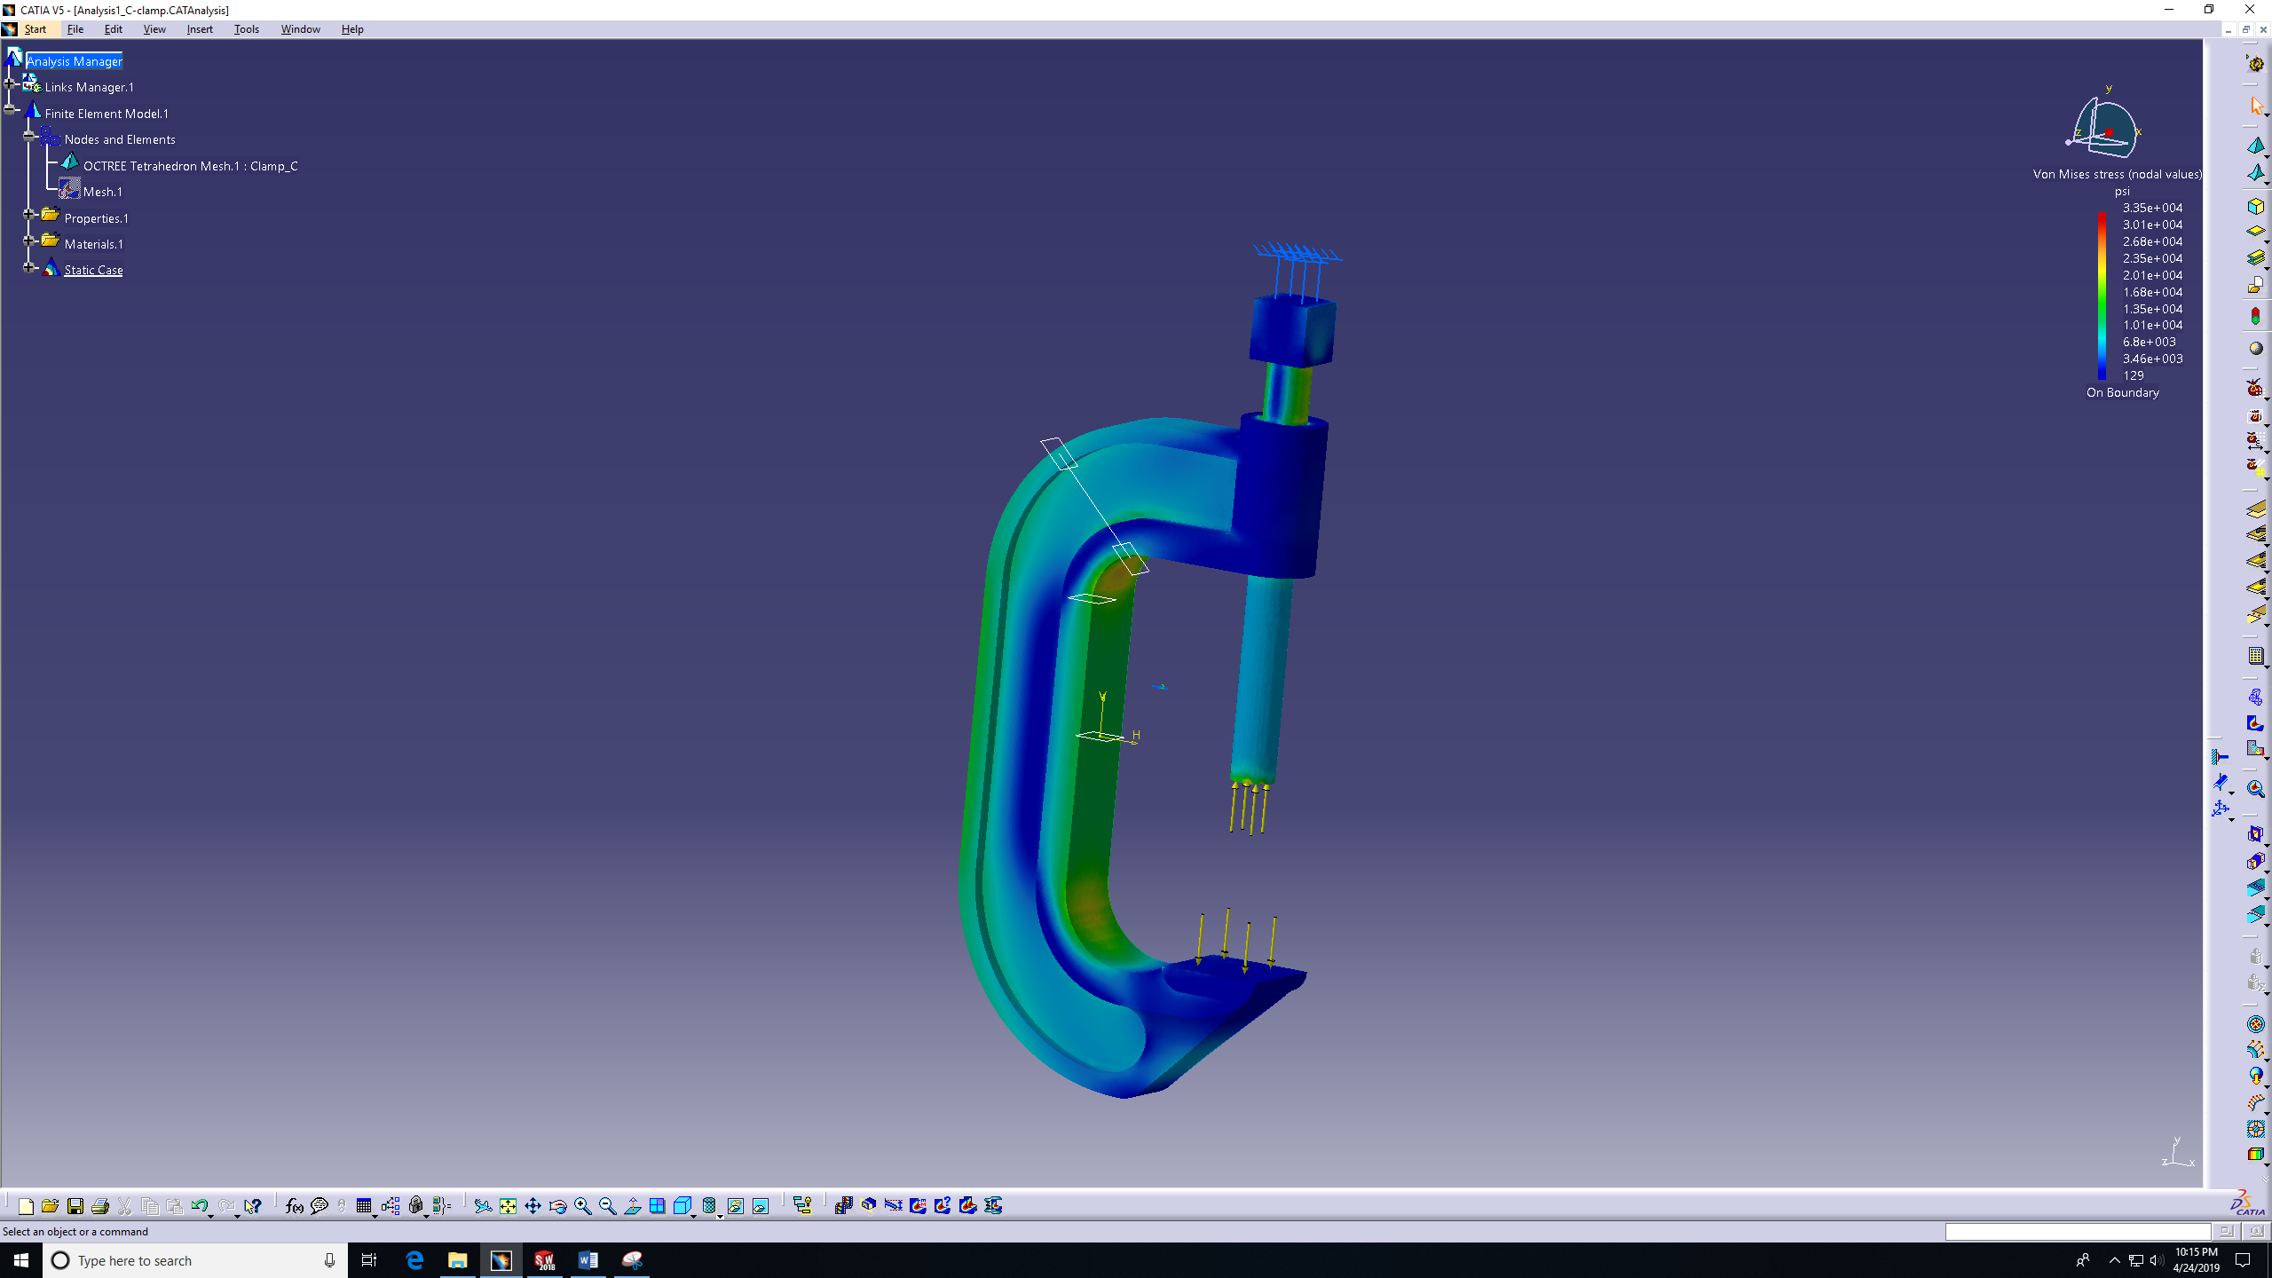
- The model can be adjusted for visual purposes by double click on the model and image edition box will show giving the visual options: Average iso, Discontinues iso, Symbol, and Text. 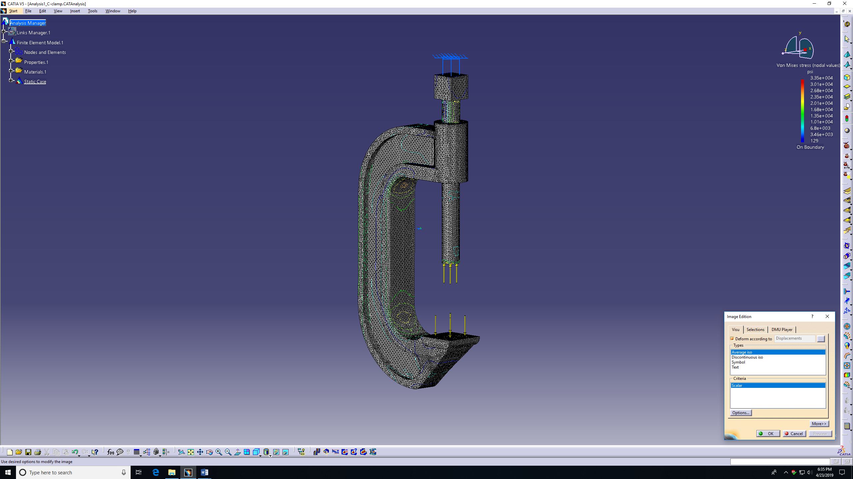
- Average iso: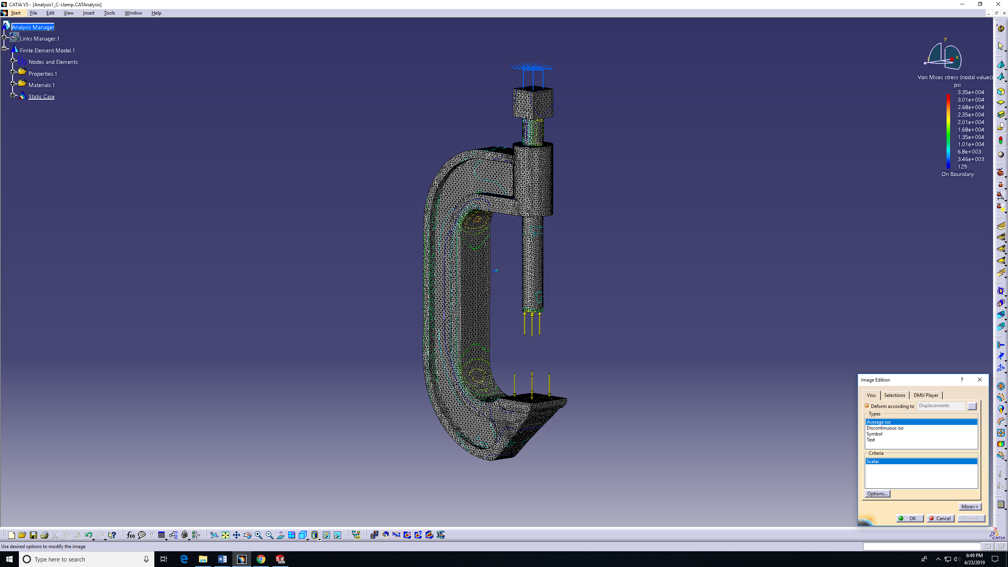
- Discontinues iso: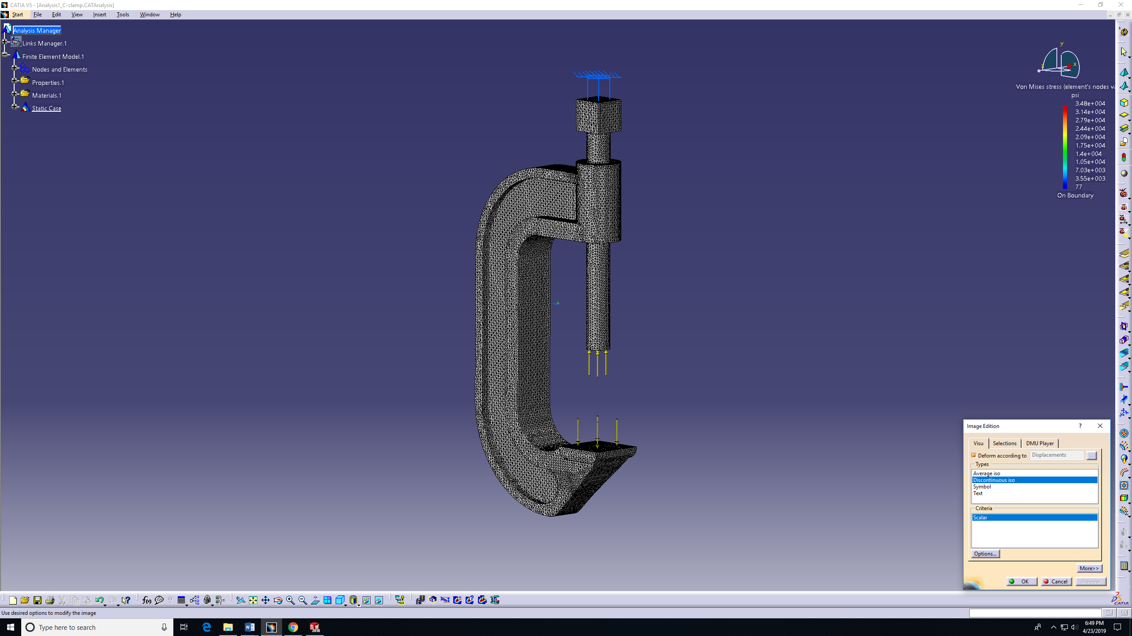
- Symbol: 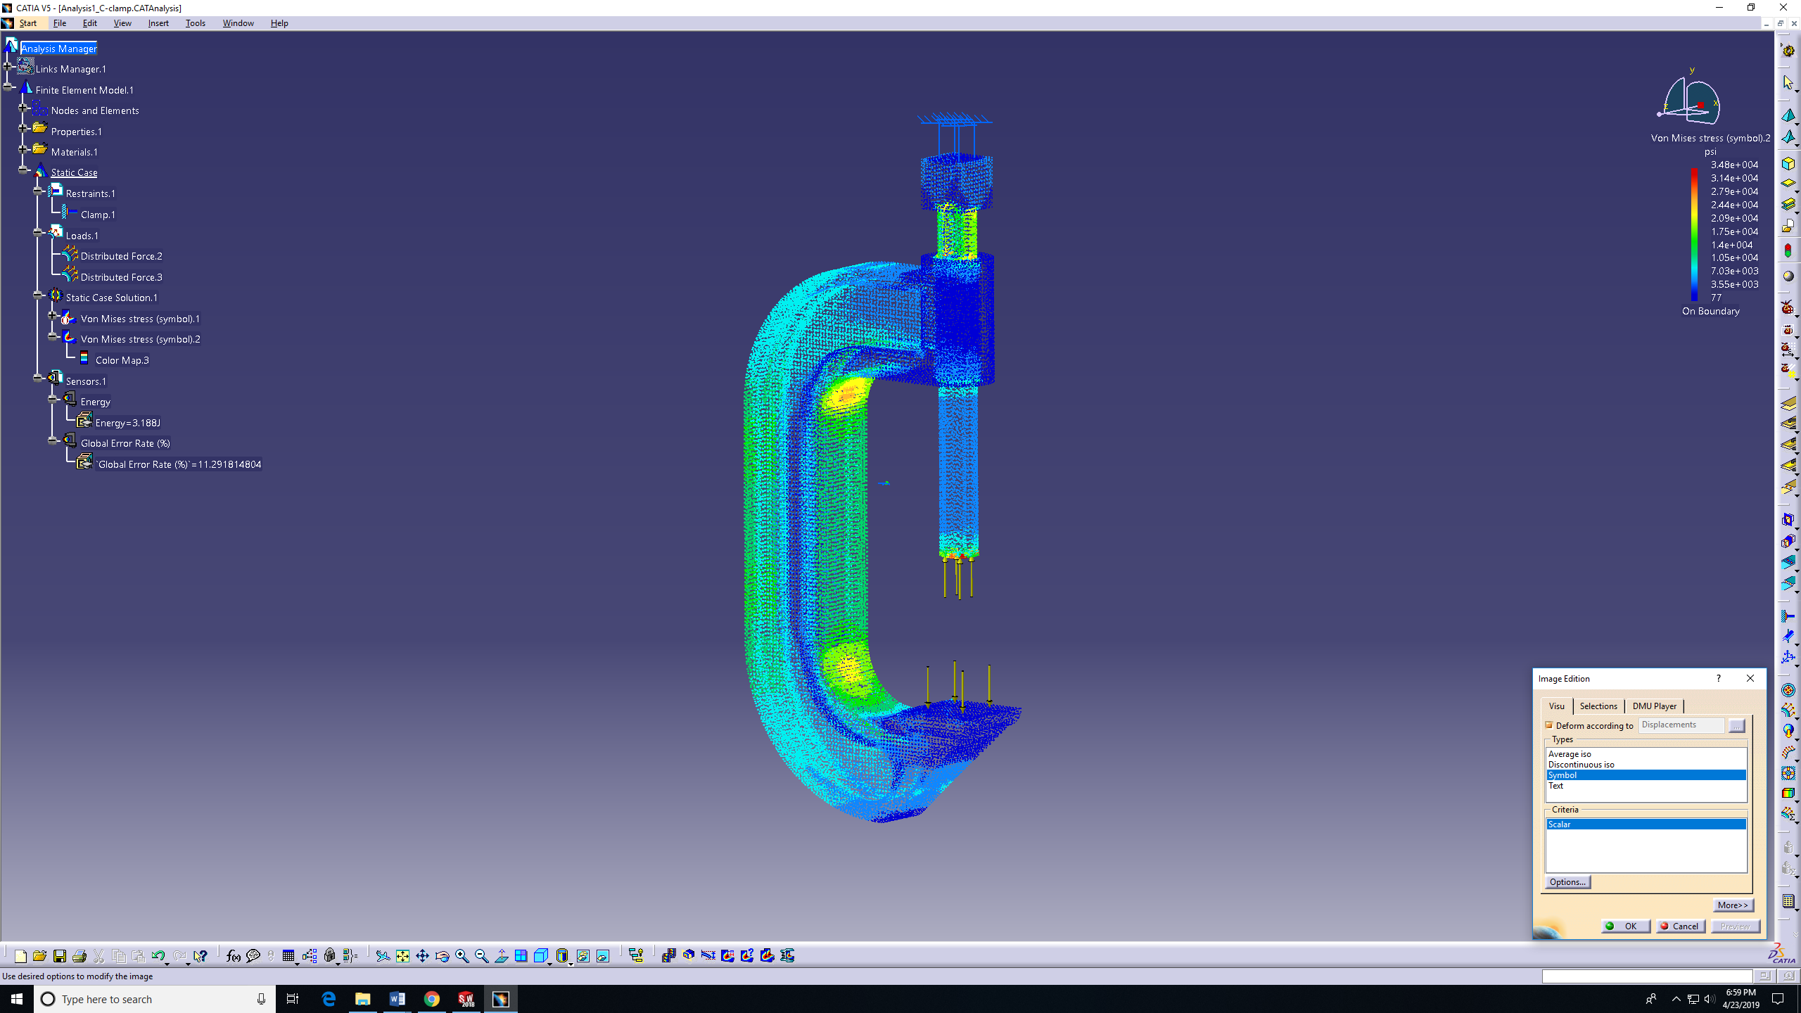
- Text: 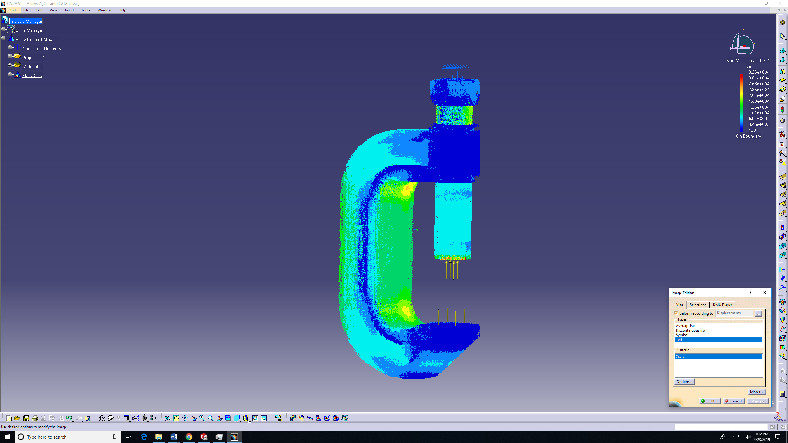

NOTE: CATIA program may lag when use “Symbol or Text” features.
- To get a clear image like the one below, go to shading.
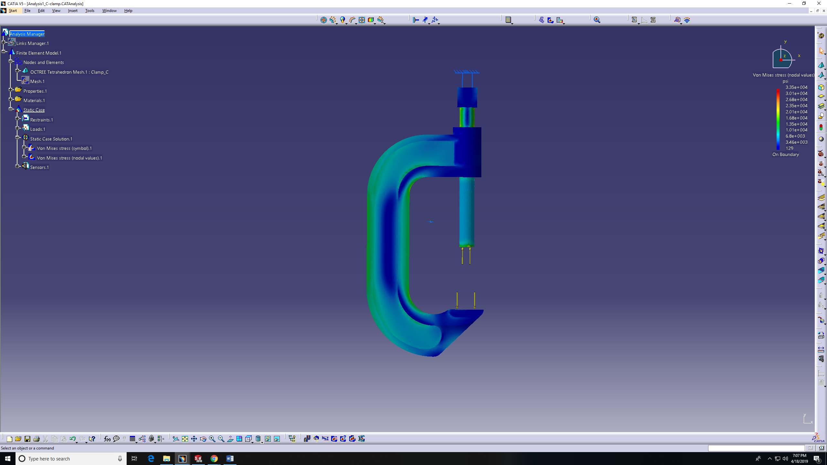
- Then choose shading with material. 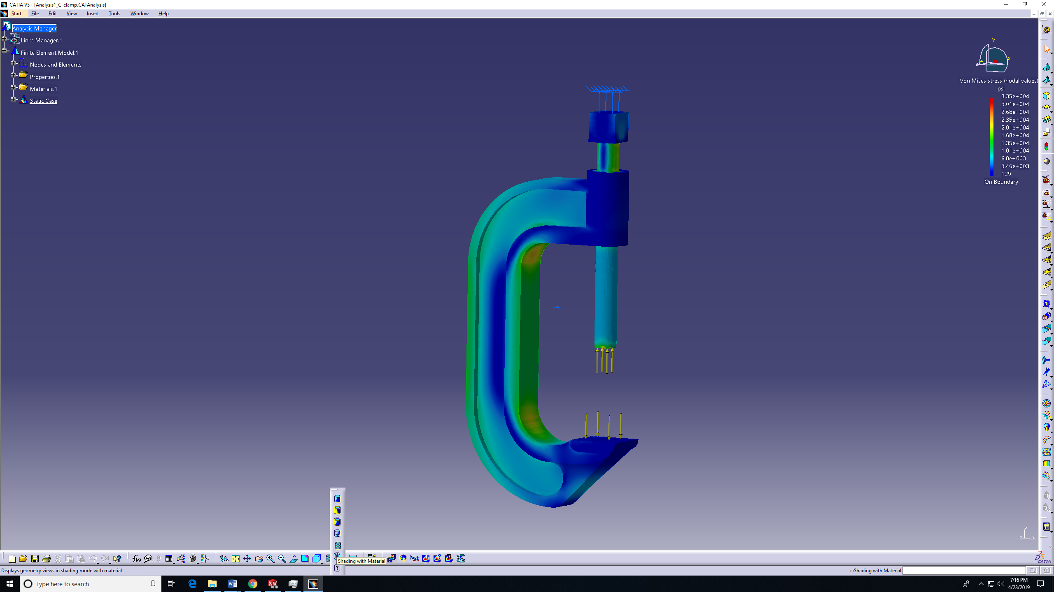

- To get the stress value, scroll the mouse over the part and a number will appear by location of the pointer.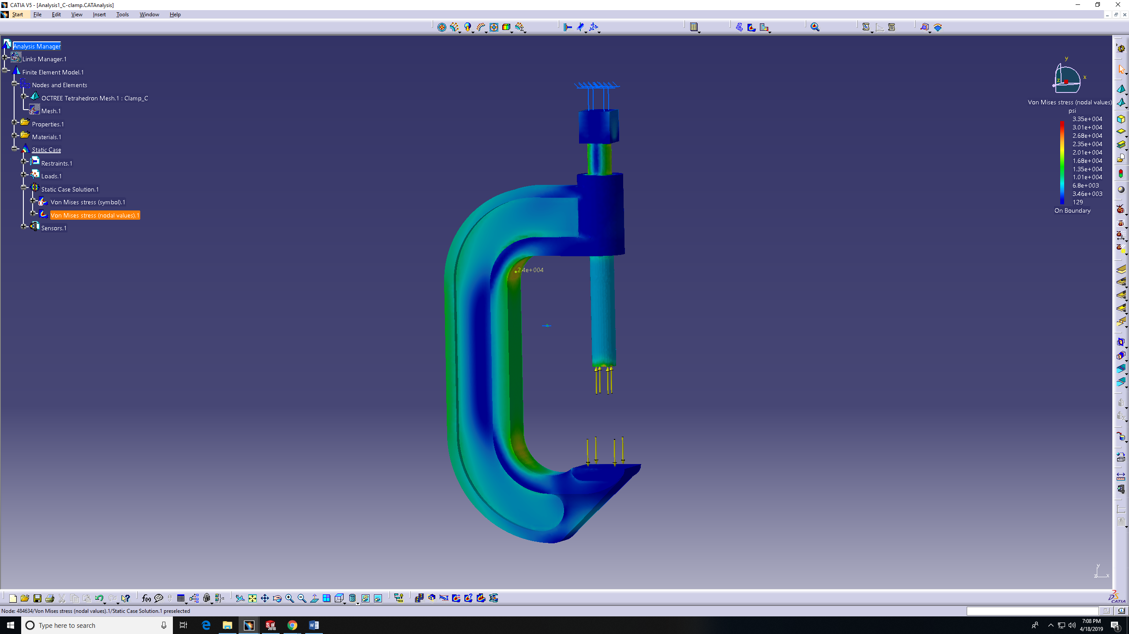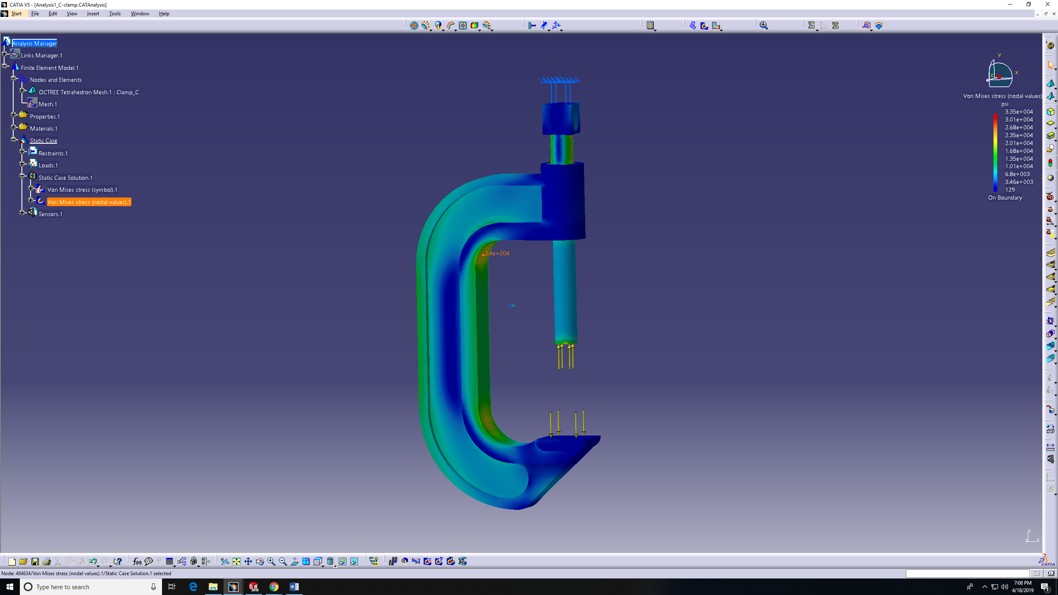
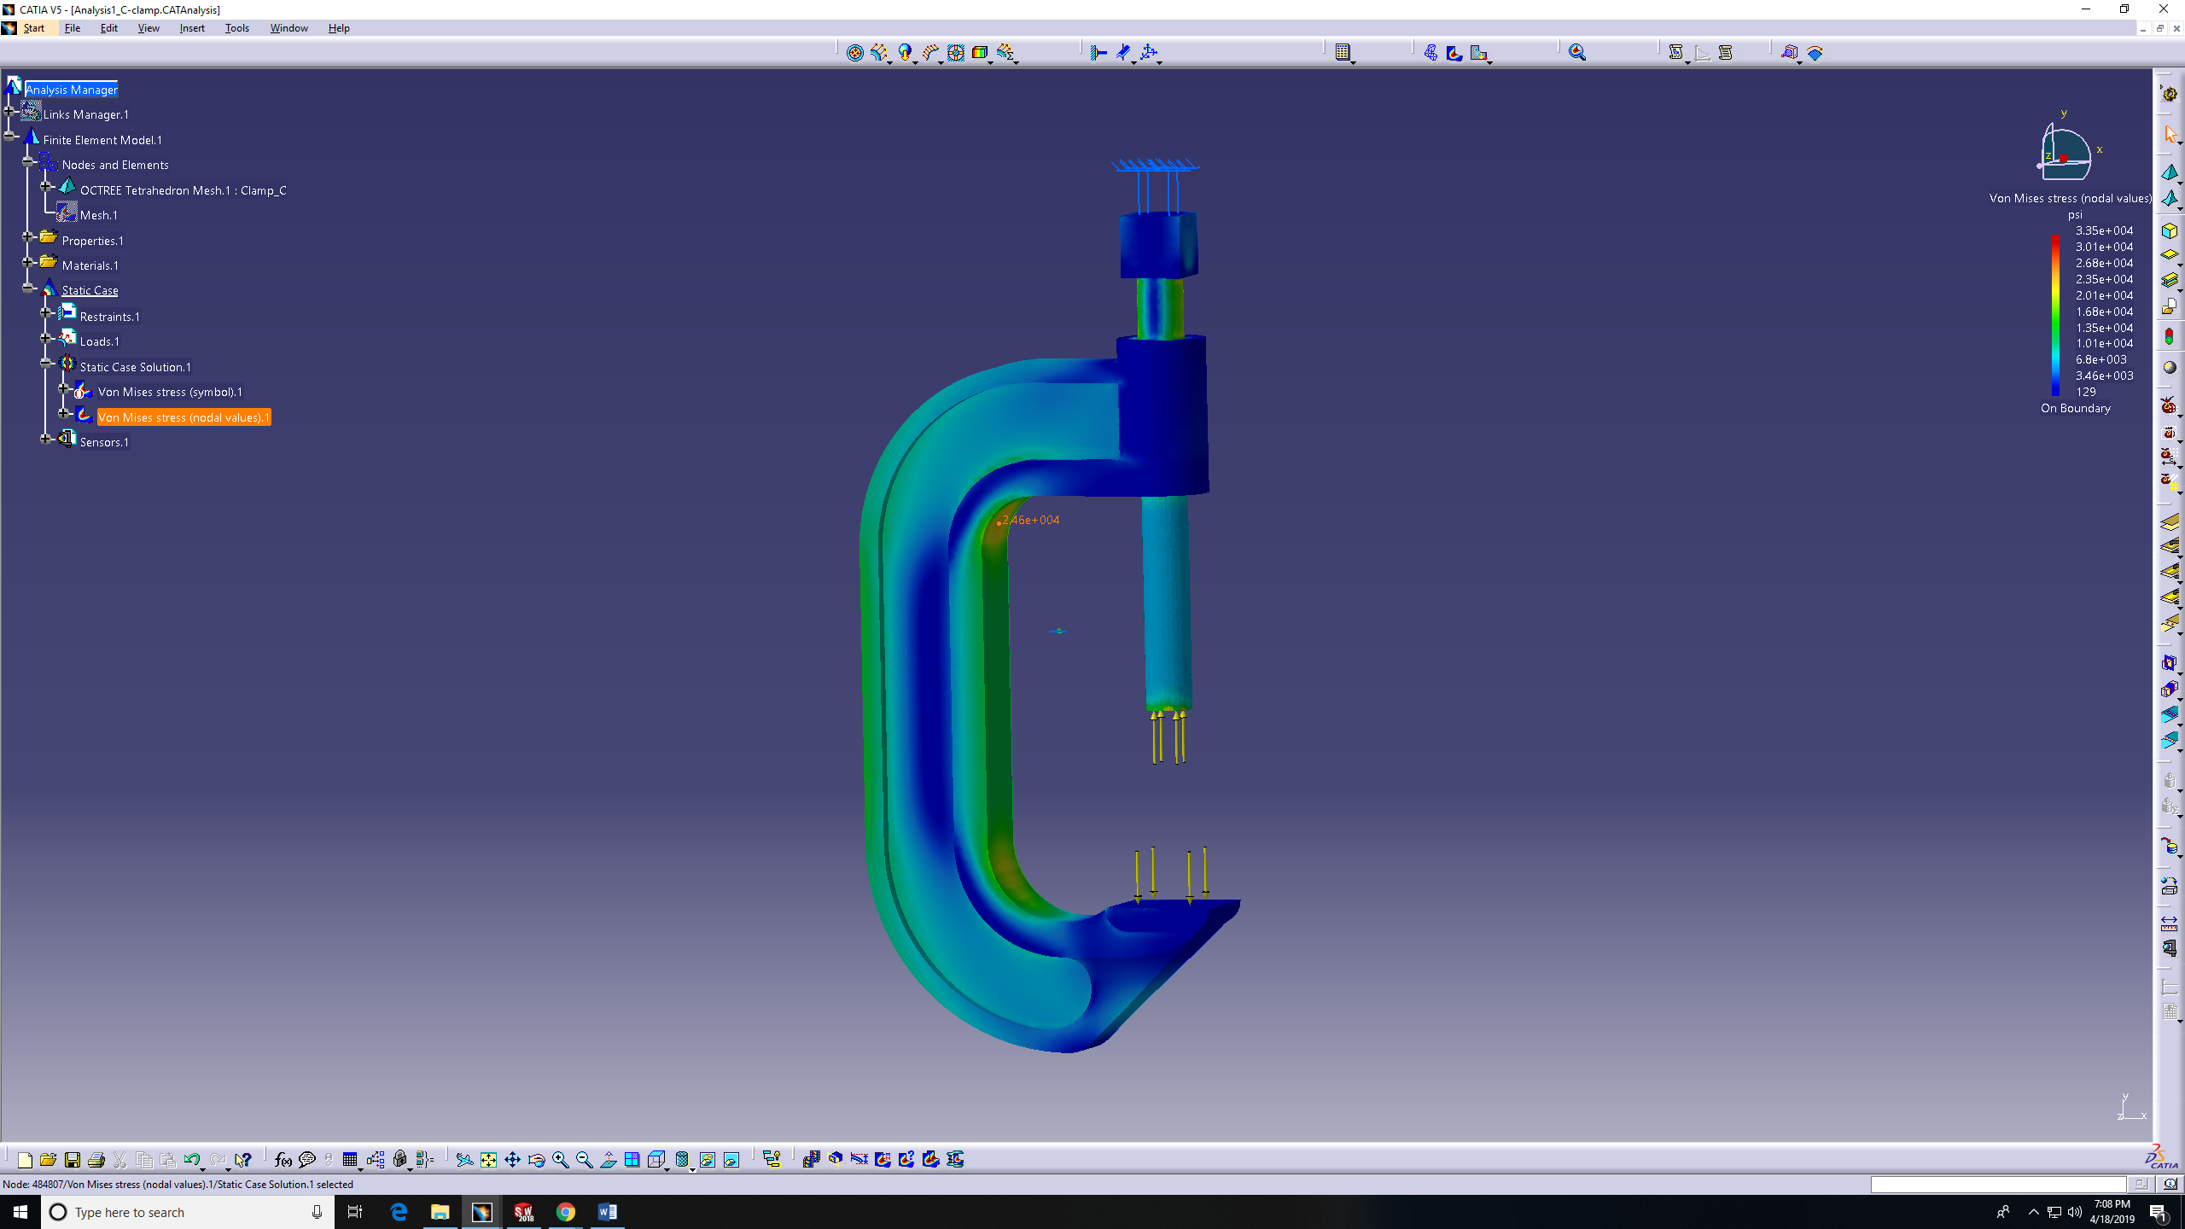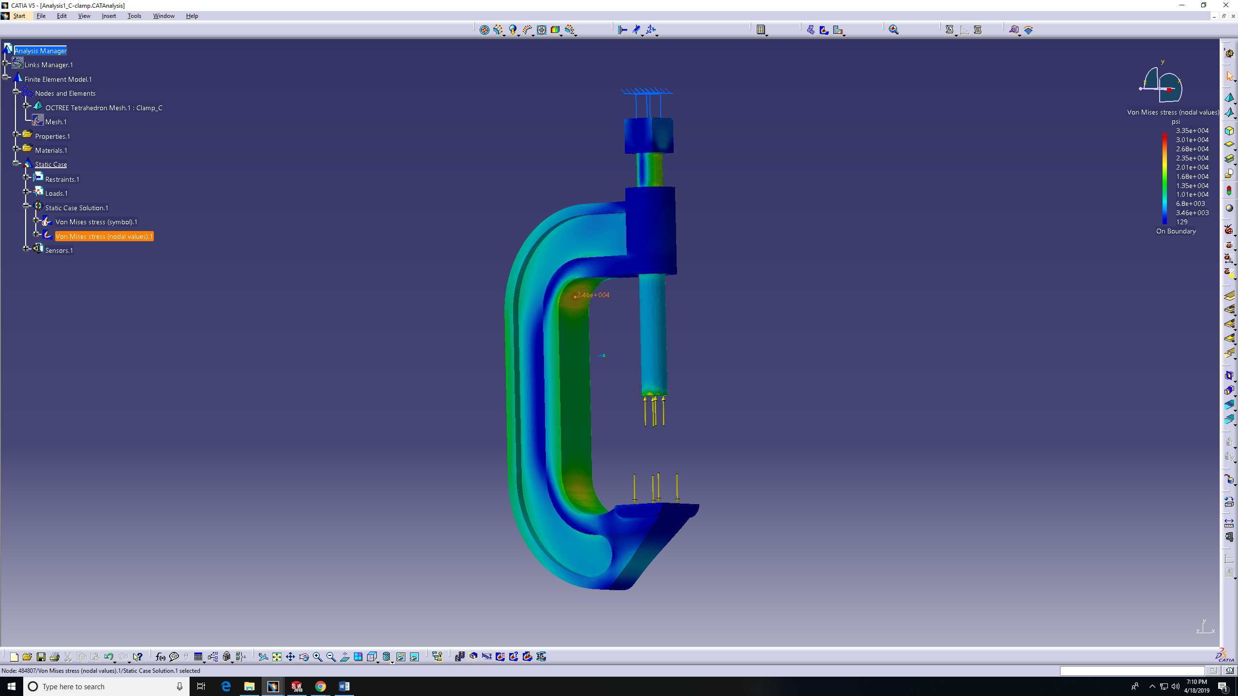

Results and Comparison
Here are the Maximum Circumferential stresses in planes AB and DE:
NOTE: the negative values represent the compression stresses.

TK solution provided by Dr. Odom
Location | TK (Psi)
AB inner surface | 14,227.5
AB outer surface | -15,054.8
DE inner surface | 18,408.7
DE outer surface | -9,879.8

SW solution
Location | SW (Psi)
AB inner surface | 14,080
AB outer surface | -15,180
DE inner surface | 25,630
DE outer surface | -10,370

CATIA solution
Location | CATIA (Psi)
AB inner surface | 13,100
AB outer surface | -13,800
DE inner surface | 21,500
DE outer surface | -9,240

Comparison between TK solution and SW
Taking the average between the Max and Min values from the previous table:
Location | TK (Psi) | SW (Psi) | % error
AB inner surface | 14,227.5 | 14,080 | 1.04
AB outer surface | -15,054.8 | -15,180 | 0.83
DE inner surface | 18,408.7 | 25,630 | 39.23
DE outer surface | -9,879.8 | -10,370 | 4.96

Justification: We notice the difference on the DE inner plane. But he AB plane results are almost the same from TK and SW.

Comparison between TK solution and CATIA
Taking the average between the Max and Min values from the previous table:
Location | TK (Psi) | CATIA (Psi) | % error
AB inner surface | 14,227.5 | 13,100 | 7.92
AB outer surface | -15,054.8 | -13,800 | 8.33
DE inner surface | 18,408.7 | 21,500 | 16.79
DE outer surface | -9,879.8 | -9,240 | 6.48

Justification: We notice the difference in all the results comparing CATIA and TK. There are several reasons for these results. As explained previously, CATIA doesn’t have the probe feature so you cannot choose exact point. The values are brought from the mesh nodes as shown next page. Also, CATIA is giving smaller results that what SW is giving.
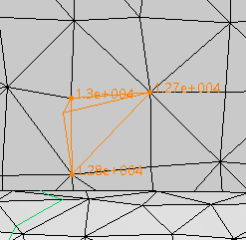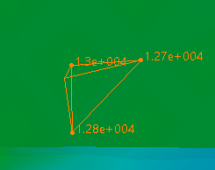

Time Comparison
Time | Mesh size = 0.1 in | Mesh size = 0.08 in
SW | 1 min and 8 sec | 8 min
CATIA | Less than 30 sec | Around 40 sec

Lessons Learned
- The largest compression stress is not located at DE plane. It’s more down toward the origin.
The largest stress in SW = 27,930 psi
The largest stress in CATIA = 24,600 Psi
- Not possible to easily recognize the max and min stresses in CATIA. On the other hand, SW has feature that tills the max and min values as shown in SW step 15.
- Try not visualizing the model using text or symbol in CATIA to avoid lagging.
- It’s harder in CATIA to read the stresses values since there is no “Probe” feature like the one in SW.
- The reason of choosing the mesh to be 0.08in, because SW will crush every time trying a smaller mesh.

